CHEMICAL CHARACTERISTICS OF SEDIMENT COLLECTED AS PART OF
THE FISHERY RESOURCE INVENTORY OF THE LOWER HACKENSACK RIVER WITHIN THE HACKENSACK MEADOWLANDS DISTRICT

A COMPARATIVE STUDY
2001-2003 & 1987-1988

NEW JERSEY MEADOWLANDS COMMISSION

MEADOWLANDS ENVIRONMENTAL RESEARCH INSTITUTE

Table of Contents

Background 3
Methods 6
Field Methods 6
Physical Properties 8
Metals 9
Organics 9
Results and Discussion 11
Sediment Texture 11
Metals 14
Sediment Metal Behavior 17
1988/2003 Comparison 19
Organic Contaminants 20
Conclusions 24
References 25

Appendix 1 Grain Size Analysis SOP 28
Appendix 2 Grain Size Calculator 30
Appendix 3 Sediment Sample Textures 2003 31
Appendix 4 Sediment Sample Textures 1988 33
Appendix 5 Sediment Sample Metal Concentrations 2003 34
Appendix 6 Sediment Sample Metal Concentrations 1988 36

Figure 1 Map of Sampling Locations 5
Figure 2 Plot of Site Textures 12
Figure 3A Spatial Distribution of Fine Material, River vs. Tributaries 13
Figure 3B Spatial Distribution of Fine Material, River Segments 13
Figure 4 Visual Depiction of Spatial Trend 17
Figure 5 Visual Depiction of Mercury Spatial Trend 17
Figure 6 Congener Specific PCB Concentrations 21
Figure 7 Mean Abundance of PCBs by Homologues 22
Figure 8 Total PCBs, DDX and Chlordane 23

Table 1 Sediment Sampling Sites 4
Table 2 Sediment Sampling Description 7
Table 3 Grain Size Classes 8
Table 4 Summary of SRM Recovery 9
Table 5 List of Target Organic Analytes 10
Table 6 Net Type Averages of Physical Properties 11
Table 7 Comparison of Fine Material Collected 12
Table 8 Criteria for Assessing Sediment Contaminants by Site 14
Table 9 Hackensack River Estuary: Average Metal Concentrations 15
Table 10 Hackensack River metal concentrations obtained in 2003 16
Table 11 Sediment Correlation Matrix 18
Table 12 Metal Comparison 1988/2003 19
Table 13 Total PCBs, DDXs and Chlordanes 20

Background

In 1987 the Hackensack Meadowlands Development Commission (HMDC) initiated a two-year fishery study of the lower Hackensack River. The purpose of the study was to provide an inventory of the fishery resources within the boundaries of the Hackensack Meadowlands District. The data was used to asses the fish population that was using the River, and to determine the extent to which the River and its tributaries provided habitat and refuge for those species. The data from the 1987-88 study was presented in the HMDC’s 1989 fishery resource inventory report (HMDC, 1989), which is frequently requested by the State and Federal resource agencies, environmental consultants and the public (Bragin et al., 2005).

The HMDC, which was renamed the New Jersey Meadowlands Commission (NJMC) on August 29, 2001 had always envisioned repeating the fishery inventory periodically to determine whether the fish community would respond to perceived water quality improvements that were occurring within the District. Therefore, in 2001, the NJMC began a new fishery resource inventory of the Hackensack River, the goal of which was to repeat the earlier study and compare the results.

Rather than simply repeat the inventory, the NJMC decided that additional studies would be beneficial. The additional studies included: an investigation of selected contaminants in fish tissue; a study of the reproductive health of the white perch; a food habits study of the white perch; an investigation of the benthic invertebrates that live in and on the river bottom; and a chemical and textural analysis of the river bottom sediments. The results of each of these companion studies are reported under separate cover, and can be obtained from the MERI library.

A total of 21 sampling locations were established during the 1987-1988 fisheries study (HMDC, 1989). The locations were selected with the assistance of the New Jersey Department of Environmental Protection (NJDEP) Bureau of Marine Fisheries. Sites were selected based on their spatial distribution along the River (within the HMD) and the suitability of deploying and retrieving each of the gear types in order to sample subtidal and shallow inshore areas of the River. The gear types were selected to match what the NJDEP Bureau of Marine Fisheries used in making collections for other fisheries studies in estuarine waters around the State.

The locations sampled during the 2001-2003 fisheries study depicted in Figure 1 replicated the 1988 sites. Due to changes in site conditions during the intervening 13 years, two sampling sites, T9 and TN1, were slightly re-located from their original 1987-1988 locations. Sediment samples were collected by the MERI fisheries team once from each sampling location during the study. Three replicate samples were collected from each location, for a total of 78 sediment samples (river trawl locations were sampled at the shallow and deep end). Table 1 lists the sediment sampling sites, indicating lower Hackensack River segment, river mile or tributary, and fisheries gear type used at each location.

This report focuses solely on the chemical and textural analysis of the river bottom sediments. Sediments were characterized by parameters helpful for measuring ecological-risk and for making comparisons between sampling locations. In the sediments, heavy metal concentrations, grain size distribution and total organic carbon content were analyzed. “These data confirm whether samples were collected in depositional zones, as indicated by relatively higher carbon values and a higher percentage of fine-grained particles, and provide a qualitative indication of bioavailability. Depositional zones are areas of highest potential contamination” (Frasco, 1997). The metals arsenic, cadmium, chromium, copper, iron, lead, mercury, nickel and zinc were analyzed in all sediment samples; while pesticides and polychlorinated biphenyls (PCB’s) content were analyzed in a sub-set of sampling locations (See Table 1).

Table 1. Sediment Sampling Sites

 | River Mile | Sampling Site | Net Type
Upper River | 12.5 | TN 6* | Trap Net
Upper River | 12.0 | GN 3 | Gill Net
Upper River | 10.9 | T5-S | Trawl Shallow
Upper River | 10.9 | T5-D | Trawl Deep
Upper River | 10.9 | TN 5* | Trap Net
Upper River | 10.6 | S 3 | Seine
Upper River | 9.3 | T4-S | Trawl Shallow
Upper River | 9.3 | T4-D | Trawl Deep
Upper River | 9.2 | TN 4* | Trap Net
Middle River
Middle River | 7.4 | S 2 | Seine
Middle River | 7.1 | TN 3* | Trap Net
Middle River | 7.0 | T3-S | Trawl Shallow
Middle River | 7.0 | T3-D | Trawl Deep
Middle River | 6.8 | GN 2 | Gill Net
Lower River | 5.4 | T2-S | Trawl Shallow
Lower River | 5.4 | T2-D | Trawl Deep
Lower River | 3.8 | T1-S | Trawl Shallow
Lower River | 3.8 | T1-D | Trawl Deep
Lower River | 3.6 | TN 1* | Trap Net
Lower River | 3.5 | S 1 | Seine
Lower River | 3.0 | GN 1 | Gill Net
Tributary
Tributary | Sawmill | T6 | Trawl
Tributary | Sawmill | TN2* | Trap Net
Tributary | Berry’s | T7 | Trawl
Tributary | Mill | T8 | Trawl
Tributary | Cromakill | T9 | Trawl
* Analyzed for organic constituents

Figure 1. Map of Fisheries Inventory Sampling Locations

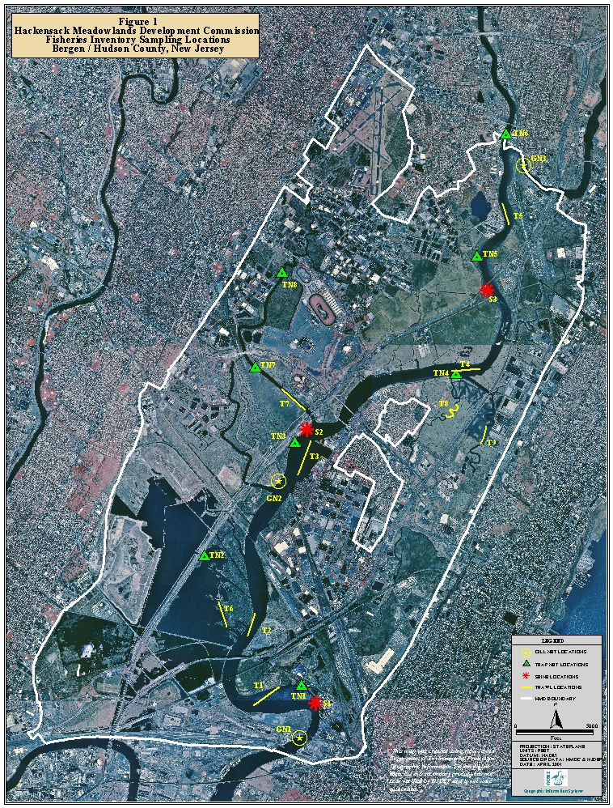

Methods

Field Methods
Sediment samples were collected using a standard 316-stainless steel Ponar grab sampler (sampling area of 0.05 m², weight ~50 lbs.), deployed from a 21 foot Privateer work skiff via a davit equipped with a battery-operated winch. The collection of sediments for chemistry and textural analyses occurred over six days between July and December of 2003, with the majority of the samples collected in December. The first step of the sediment collection process was to anchor the boat above the sampling location. Water depth was ascertained using a Garmin model 160 Blue depthfinder. Next, the Ponar grab was arranged in the open position and it was slowly lowered through the water column using a sufficient length of 5/8 inch line until it contacted the sediment. Once the Ponar grab was on the bottom, the line was allowed to go slack, and was then given a sharp tug to release the closing mechanism. As the Ponar grab closed, it scooped up approximately 8.2 liters of sediment (i.e., for a full grab in soft sediments. At locations where the substrate was clay or hard-packed sediments, the Ponar was dropped from a height of one to two feet above the sediment surface in an attempt to collect a sufficient volume of material for the required laboratory analyses in one grab). The winch was then used to raise the Ponar grab containing the collected sediment to the surface. The davit was swung over the deck of the boat and the Ponar grab was slowly lowered into a laboratory cleaned plastic tub (18.5 inches long x 14 inches wide x 7 inches high). Water overlying the sediment sample (if any) was slowly decanted through the screens at the top of the Ponar grab sampler and was discarded. The Ponar grab was then opened, releasing the collected sediments into the plastic tub. Any sediment adhering to the walls of the Ponar grab were scraped into the tub using a plastic scoop. The sediments were homogenized using the same plastic scoop, and were transferred to properly labeled, pre-cleaned, three-liter glass jar with a Teflon lid, and placed on ice in coolers for transfer to the Meadowlands Environmental Research Laboratory (MERI) laboratory. Three replicate samples were collected at each sampling location. Details regarding the collection location, date and time of sample collection, water depth, observations related to the sediments collected in each replicate sample, and any other pertinent observations were recorded in a field notebook, and are summarized in Table 2.

The Ponar grab sampler was cleaned using site water and a hard-bristle scrub brush to remove any visible sediment before the next replicate sample was collected. After the third replicate sediment sample was collected at a particular sampling location, the Ponar grab sampler was decontaminated using a triple-step wash procedure that included an initial wash and scrub using site water, followed by an Alconox detergent wash/scrub and distilled water rinse, followed by a 10% nitric acid rinse, distilled water rinse, and finally an acetone rinse followed by a final distilled water rinse. The Ponar grab was then placed in a laboratory cleaned plastic tub, ready to be used at the next sediment collection location.

Table 2. Sediment Sampling

SITE | Date Sampled | Water Depth (ft) | Visual Description of Sediment | Additional Notes
GN1 | 12/04/03 | ~15 | grey sandy mud (Rep 2 produced a sheen) | Rep.1 required 3 grabs, and Rep 2 required 2 grabs
GN2 | 12/29/03 | 9 | sticky grey clay | Needed 2 grabs for each replicate
GN3 | 08/05/03 | 8.4 | very soft black mud (consistency of mayonnaise) | Each replicate was a full grab
S1 | 12/04/03 | 4 | mud underlain by sand & gravel (mud produced a sheen) | Replicate 1 required 3 grabs
S2 | 12/04/03 | 3 | sandy mud | Replicate 1 required 3 grabs
S3 | 12/12/03 | 2.5 | soft black mud w/ thin brown surface layer | Each replicate was a full grab
T1 deep | 12/18/03 | 16 | stiff blackish-grey clay w/ a thin brown surface layer w/ sand & shell hash | Amphipods noted in samples
T1 shallow | 12/18/03 | 11 | stiff grey clay | Each replicate was between 1/2 to 3/4 full
T2 deep | 12/18/03 | 19 | brown mud w/ some sand. Rep. 1 produced a slight sheen | Replicates 2 & 3 required 2 grabs each
T2 shallow | 12/18/03 | 11 | brown sandy mud w/ organic matter & silvery sheen | Each replicate was ~1/4 full
T3 deep | 12/18/03 | 15 | soft black mud w/ thin (~1.5 - 2 inch thick) brown surface layer | Each replicate was a full grab
T3 shallow | 12/18/03 | 4 | soft black mud w/ thin brown surface layer | Each replicate was a full grab
T4 deep | 12/12/03 | 14 | hard sticky grey clay | Needed 2 grabs for each replicate
T4 shallow | 12/12/03 | ~7 | soft black mud | Each replicate was a full grab
T5 deep | 07/11/03 | 16.8 | brownish-black mud (consistency of mayonnaise) (no odor) | Each replicate was a full grab
T5 shallow | 07/11/03 | 8.3 | black mud (consistency of mayonnaise) (with a slight chemical odor) | Replicates 1&2 were full grabs, Rep 3 was 3/4 full
T6 | 12/04/03 | 12 to 15 | hard grey clay | ~6 grabs needed for each replicate
T7 | 12/29/03 | 18 | soft black mud w/ thin brown surface layer, anaerobic odor, Phrag stalks | Each replicate was a full grab
T8 | 12/29/03 | 9.8 | brownish-grey soft mud w/ many Phragmites stalks, anaerobic odor | Amphipods and chironomid larvae noted
T9 | 12/29/03 | 10 | very soft black mud (consistency of mayonnaise) w/ worm tubes on surface | Each replicate was a full grab
TN1 | 08/05/03 | 4.2 | brownish-grey clayey mud | Each replicate was ~3/4 full
TN2 | 08/05/03 | 5.1 | greyish-black mud with thin brown layer on top | Each replicate was a full grab
TN3 | 12/04/03 | 5 | blackish-grey mud w/ thin brown surface layer | Each replicate was a full grab
TN4 | 12/12/03 | 3 | sticky black mud | Each replicate was between 1/2 to 3/4 full
TN5 | 12/12/03 | 4 | sticky black mud w/ a very soft top layer | Each replicate was a full grab
TN6 | 08/05/03 | 2 | soft black mud (consistency of mayonnaise) (no odor or sheen) | Each replicate was a full grab

Physical Properties of Sediment
Sediment texture (particle-size), percent moisture and organic matter were determined for each sample in order to characterize the sediment and to help clarify the difference between site metal concentrations. Statistics performed to discern differences between sites normalized metal concentrations to the percentage of fine material contained in each sample. The American Society for Testing and Materials and (ASTM 2003) standard methods D 422 (particle-size) and D 2974 (moisture and organic matter) were utilized.

Appendix 1 contains the standard operating procedure for particle-size analysis. In summary:
- The soil sample is dried at room temperature.
- Sieve the ground sample through a No. 10 (2 mm) sieve using the Rotasift for 5 minutes. This material when weighed is the coarse fraction.
- The material passing through the sieve is mixed with a dispersing agent until homogenized.
- Transfer soil-water slurry (sample in dispersing agent) from its beaker into a glass sedimentation cylinder and fill to 1000mL with DI/distilled water.
- Record both hydrometer (specific gravity) and temperature readings at intervals of 2, 5, 15, 30, 60, and 150 minutes after sedimentation begins.
- When the hydrometer/temp readings are finished, pour the cylinder through a No. 230 (63 um) sieve. Dry the material retained on the No. 230 sieve at 105º C.
- Once dried, break up aggregations and perform a final sieve analysis of the material through a No. 40 (425 um), No. 60 (250 um), and a No. 120 (125 um) sieve (simultaneously) for 20 minutes. Weigh and record the mass of material retained on each sieve and the material that passed through all three sieves. This is the mass of sandy material.

A calculator using Excel (Appendix 2 contains a sample spreadsheet) was devised to convert hydrometer readings to grain size classifications. This is necessary to distinguish between clay and silt size material (collectively referred to as % fines).

Table 3. Grain Size Classes

Sieve | Grain Size | Classification
4 | 4.75 mm | Pebble
10 | 2.00 mm | Granule
40 | 425 um | Coarse Sand
60 | 250 um | Medium Sand
120 | 125 um | Fine Sand
230 | 62.5 um | Very Fine Sand
<230 | 5 um | Silt
 | <5 um | Clay

ASTM Method D 2974 describes the gravimetric determination of both moisture content and organic matter. Percent moisture was determined by drying the sample for 16 hours at 105º C. Organic matter (ash content) was determined by igniting the oven dried sample from moisture content in a muffle furnace at 550 °C.
Metals analyses
A sufficient amount of sediment (1-2 g wet weight, yielding 0.4-0.8 g dry weight) was oven-dried, weighed, and mineralized in 10 ml Trace Metal Grade HNO3 in Teflon bombs in a microwave digester. The resultant mineralized solution was boiled off to near dryness, restored to 25 ml volume with 1% HNO₃, and divided. Twenty ml were used by the MERI laboratory for analysis of Cr, Cu, Cd, Fe and Pb by flame atomic absorption spectrophotometry (AAS). The remaining 5 ml were used by UMDNJ for Hg analysis by cold-vapor AA in a Bacharach MAS-50D mercury analyzer and for As analysis by hydride generation AA in a Perkin-Elmer 603 spectrophotometer. All metal analyses in 1988 were performed in the HMDC Laboratory (now MERI Laboratory) using AAS. Instrumentation in the MERI laboratory was upgraded in 2001.

One Standard Reference Material (SRM) was analyzed with every ten samples. Table 4 is a summary of the percent recovered, which ranged from 72.4% for Chromium to 103% for Cadmium in 2003, and 69.9% for Zinc to 120% for Cadmium in 1988. Arsenic, Mercury and Iron were not analyzed in 1988.

Table 4. Summary of SRM Recovery

Metal | % Recovery
 | 1988 | 2003
Arsenic |  | 75.7
Cadmium | 120 | 103
Chromium | 105 | 72.4
Copper | 92.4 | 99.7
Mercury |  | 91.2
Lead | 108 | 95.9
Nickel | 115 | 95.6
Zinc | 69.9 | 82.0
Iron |  | 81.9

Organic analyses
The concentrations of a suite of polychlorinated biphenyls (PCBs) congeners as well as organochlorine pesticides (OCPs) such as DDT, DDE, DDD, and chlordanes were quantified in six sediment samples at the Patrick Center for Environmental Research, The Academy of Natural Sciences, Philadelphia, PA (Ashley and Velinsky 2003).

Contaminant analyses were performed for the parameters listed in Table 5. For extraction, samples previously frozen were thawed and 5 to 10g of wet sediment was sub-sampled using a stainless steel spatula. An additional 2 to 5g sub-sample of sediments was taken for moisture analysis. The sample was placed in a Soxhlet extractor with approximately 200 mL of dichloromethane (DCM) for a minimum of 18 hours. Activated copper was added to the extraction apparatus to minimize the interference from sulfur for sediment samples.

Lipids were removed from sample extracts by gel permeation chromatography (GPC) using DCM as the mobile phase. The collected fraction containing analytes was concentrated by roto-evaporation and a N₂ stream. Solid-liquid chromatography using florisil was performed as an additional clean-up step. Using this technique, PCBs (as well as heptachlor, nonachlors, and DDEs) are eluted from the chromatographic column containing florosil using petroleum ether (F1 fraction). The remaining organochlorine pesticides are eluted using 50:50 petroleum ether and dichloromethane (F2 fraction).

Eighty congener-specific PCBs (or PCB combinations) and 22 organochlorine pesticides (Table 5) were analyzed using a Hewlett Packard 5890 gas chromatograph equipped with a ⁶³Ni electron capture detector and a 5% phenylmethyl silicon capillary column. The identification and quantification of PCB congeners follows the ‘610 Method’ in which the identities and concentrations of each congener in a mixed Aroclor standard (25:18:18 mixture of Aroclors 1232, 1248 and 1262) were determined by calibration with individual PCB congener standards. Congener identities in the sample extracts are based on their chromatographic retention times relative to the internal standards added. In cases where two or more congeners cannot be chromatographically resolved, the combined concentrations were reported (Table 5). Organochlorine pesticides (OCPs) were identified and quantified based on comparisons (retention times and peak areas) with a known calibration standard prepared from individual compounds (Ashley and Velinsky 2003).

Table 5. List of target organic analytes

Polychlorinated Biphenyls (PCBs) Congeners |  |  | Organochlorine Pesticides (OCPs)
1 | 40 | 163+138 | o,p DDE
3 | 100 | 158 | p,p DDE
4+10 | 63 | 129+178 | o,p DDT
7 | 74 | 187+182 | p,p DDT
6 | 70+76 | 183 | o,p DDD
8+5 | 66+95 | 128 | p,p DDD
19 | 91 | 185 | Alpha BHC
12+13 | 56+60 | 174 | Beta BHC
18 | 101 | 177 | Delta BHC
17 | 99 | 202+171 | Lindane
24+27 | 83 | 157+202 | Heptachlor
16+32 | 97 | 172+197 | Heptachlor Epoxide
29 | 87+81 | 180 | Oxychlordane
26 | 85 | 193 | Gamma Chlordane
25 | 136 | 191 | Alpha Chlordane
31+28 | 77+110 | 199 | Cis nonachlor
53+33+21 | 82 | 170+190 | Trans nonachlor
22 | 151 | 201 | Dieldrin
45 | 135+144 | 203+196 | Endrin
46 | 107 | 189 | Aldrin
52 | 149 | 208+195 | Endosulfan I
49 | 118 | 207 | Endosulfan II
47 | 131 | 194
48 | 146 | 205
44 | 153+132+105 | 206
37+42 | 141 | 209
41+71 | 137+176

Results and Discussion

Sediment Texture
Table 6 summarizes the average percent fine material (sum of the silt and clay fractions), organic matter (OM) and moisture content grouped by net type. On average, the seine locations had the least amount of fine sediment. This is an artifact of the manner in which the sites were selected. Since the seine net was walked through the water and the net hauled up onto the shoreline at each seine location, sites that could not be easily traversed (i.e., those with thick mud) were not selected. Areas chosen as seine collection locations generally had a firm bottom (i.e., were lacking in fines). On the other hand, the trap net sites were selected to sample nearshore areas which were too muddy to seine. The trap nets were staked into mudflats at the selected locations that were close to shore, hence the high average percentage of fine material in the trap net samples. Intermediate between the seine and trap net locations were the gill net and trawl locations, which were generally located in deeper waters of the Hackensack River, or in the tributaries. The higher energy of the flowing river at some locations does not allow for the settlement of much fine material (e.g., GN1 and T2), while other sampling locations were clearly in areas of lower energy which were depositional in nature (e.g., T1 and T5).

Table 6. Net Type Averages of Physical Properties

Net Type | # of Locations | % Fines | %  OM | %  Moisture
Seines | 3 | 40 | 7.7 | 50
Gill Nets | 3 | 61 | 7.9 | 51
Trawls | 14 | 70 | 9.8 | 60
Trap Nets | 6 | 82 | 12.0 | 65

The surface area of particles increases as the size of particles decreases; as organic matter is often found as coatings on particles, it is reasonable for fine material and organic matter to co-vary as demonstrated by the net type averages. The moisture content of samples introduces the notion that opportunities for interchange between solid and liquid phases in the benthic environment are plentiful. In fact, the complexity of the system described by these parameters plays a strong role in the metal concentrations found in our samples.
Table 7 describes the texture of material sampled in the current and previous studies. Overall, the percentage of fines in the samples has remained relatively consistent; averaging 72% in 1988 and 69% in 2003. A plot of the data in Figure 2 reveals the temporal relationship in better detail. At Site T5 Deep, for example, fine material was relatively depleted in 1988 compared to 2003. This site is located in the channel of the River opposite the PSE&G Bergen Generating Station power plant; between 1988 and 2003 the cooling regime for this plant was converted from using river water to self contained cooling towers. This removed a thermal discharge plume which likely scoured the fine material from the river channel, providing a possible explanation for this change. Site S1 is also relatively depleted in fine material. The site is located along the bank of the river where a strong current provides persistent scouring; but no change in conditions has occurred to explain the difference between the intervening years. Figure 2 also illustrates that one goal in the sampling design was met; collection sites were successfully replicated. This conclusion is supported by calculation of the population correlation coefficient between the two data sets: r = 0.73.

Table 7. Comparison of Fine Material Collected, 1988/2003

Sample Site | 1988 | 2003 | Difference
GN1 | 11.5% | 19.1% | 7.6%
GN2 | 73.0% | 73.7% | 0.7%
GN3 | 98.2% | 89.0% | -9.2%
S1 | 41.5% | 1.80% | -39.7%
S2 | 40.3% | 27.7% | -12.6%
S3 | 97.3% | 91.3% | -6.0%
T1 (deep) | 55.1% | 70.6% | 15.5%
T1 (shallow) | 56.4% | 74.6% | 18.2%
T2 (deep) | 17.6% | 19.5% | 1.9%
T2 (shallow) | 11.0% | 40.2% | 29.2%
T3 (deep) | 92.8% | 87.5% | -5.3%
T3 (shallow) | 91.0% | 81.2% | -9.8%
T4 (deep) | 88.9% | 60.9% | -28.0%
T4 (shallow) | 93.9% | 68.6% | -25.3%
T5 (deep) | 14.8% | 84.7% | 69.9%
T5 (shallow) | 96.7% | 79.6% | -17.1%
T6 | 94.8% | 76.6% | -18.2%
T7 | 94.6% | 84.6% | -10.0%
T8 | 91.4% | 84.0% | -7.4%
T9 | 92.5% | 86.4% | -6.1%
TN1 | 76.3% | 83.6% | 7.3%
TN2 | 94.8% | 86.5% | -8.3%
TN3 | 96.0% | 78.6% | -17.4%
TN4 | 89.4% | 76.7% | -12.7%
TN5 | 77.6% | 80.1% | 2.5%
TN6 | 84.8% | 85.6% | 0.8%
Average | 72.0% | 68.9% | -3.1%

Figure 2. Plot of Site Textures
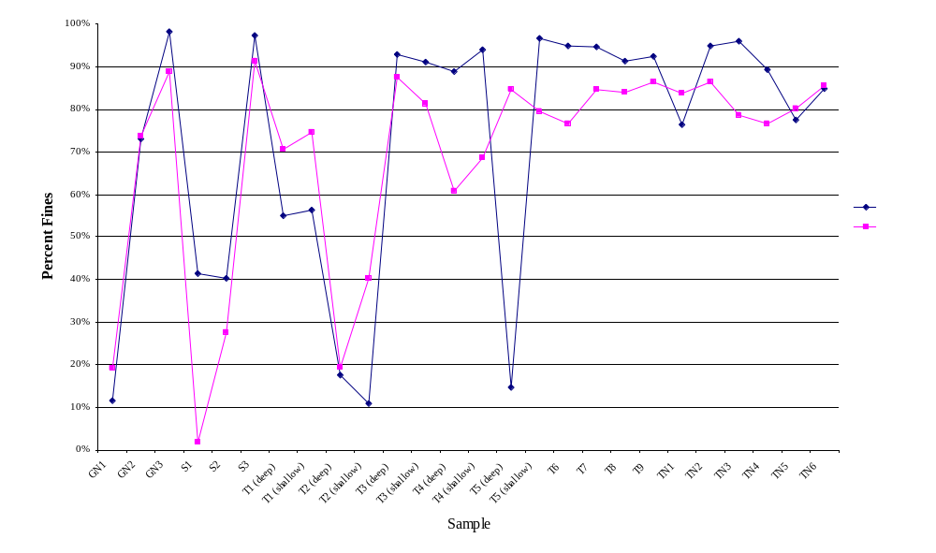

The percentage of fine material helps describe the sedimentary character of the estuary, both spatial and temporal. The sampling sites covered nine miles of the river and the major tributaries that are within the Hackensack Meadowlands District. Grouping the river sampling sites spatially can reveal differences between the lower, middle and upper part of the river within the District. Refer to Table 1 for the grouping of sites. Note that each river segment is separated by at least 1.5 river miles. Because of the strong influence of net type on sediment characteristics, an attempt was made to include a sampling from each net type in each segment. Exceptions are the absence of a gill net in the upper part of the river and a seine in the tributaries.

Figure 3A compares the average of fine percentages found in the tributaries and river in 1988 and 2003: Tributaries contain finer material then the river; the river hasn’t changed during the 15 year interval between sampling; and there has been a 12% reduction in the percentage of fine material found in tributary samples. The composition of fine material is a function of hydrodynamics. As energy in the water column dissipates, finer material is deposited. The River would naturally have higher energy, with finer material being carried until deposition occurs in mudflats, along the shorelines and in the tributaries. Because the relative amount of fine material is very dynamic, it is difficult to draw conclusions from this data; for example, the increased energy from storm events can redistribute fine material in the short term that would mask long term changes in the River.

Figure 3A. Spatial Distribution of Percent Fines:
River vs. Tributaries
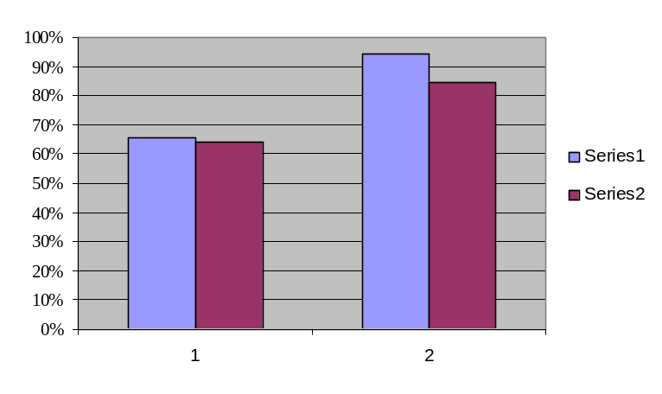
1988

2003

River Tributaries

2003

Figure 3B. Spatial Distribution of Percent Fines: River Segments
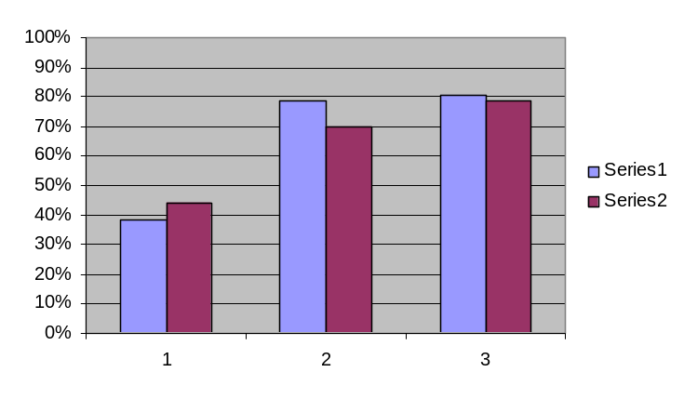
1988

2003

Lower Middle Upper

2003

Figure 3B compares the average of fine percentages found in the three segments of the river in 1988 and 2003: The average percentage found in the lower river has increased 13%; the middle part of the river has decreased by 13%; and the upper part of the river has remained relatively unchanged (2% decrease). Appendices 3 and 4 contain the complete grain size analysis for sediments collected in 1988 and 2003.

Metals
The metals and organic chemicals selected for analysis are contaminants known to bioaccumulate. The organics and mercury bioconcentrate, i.e., accumulating to higher levels (typically an order of magnitude) with each trophic level, making them of special concern (Weis 2005). The discussion which follows will include a description of the spatial distribution of metal concentrations collected in 2003 and the factors affecting that distribution; and a comparison between data collected in 2003 and 1988 using sediment quality criteria as a measure of ecosystem quality. A complete listing of concentrations obtained in 2003 and 1988 appears in Appendices 5 and 6.

There are no absolute chemical concentrations that correspond to sediment toxicity, but “Effects Range Low” (ERL) and “Effects Range Median” (ERM) values are used as guidelines in assessing sediment contamination. ERM is the median concentration of a contaminant observed to have adverse biological effects in the literature studies examined (Long et al 1995). A more protective indicator of contaminant concentration is the ERL criteria, which is the 10th percentile concentration of a contaminant represented by studies demonstrating adverse biological effects in the literature. Ecological effects are not likely to occur at contaminant concentrations below the ERL criterion (USEPA 2004, p. 12).

Table 8. Criteria for Assessing Sediment Contaminants by Site
(USEPA 2004, p. 17)

Rating | Criteria
Good | No ERM concentrations are exceeded, and less than five ERL concentrations are exceeded.
Fair | Five or more ERL concentrations are exceeded
Poor | An ERM concentration is exceeded for one or more contaminants.

Table 8 describes qualitative ratings for sites based on ERM and ERL criteria. Based on the EPA’s sediment contamination assessment criteria, the ecological condition of the Hackensack River estuary sediments in 2003 was Poor; the average concentration of one contaminant, mercury, exceeds the ERM. Table 9 provides a comparison of average metal concentrations obtained in 1988 and 2003 to the ERM and ERL criteria. Metals which exceeded the ERM criteria are printed in red. In 1988, three additional metals. cadmium, copper and nickel exhibited concentrations that would have exceeded the ERM criteria. The improvement in sediment quality in the 15 years between studies is depicted in the table as the high concentrations of cadmium, copper and nickel are no longer experienced in these estuarine sediments.

Table 10 represents the average metal concentration of three replicates collected at each site. The organization of the table by river miles and tributaries with coloration of concentrations exceeding the ERL sediment criteria (See Table 9), allows for a visual representation of spatial trends. The distribution of ERL exceedences (five or more per site) suggests that with two exceptions, S-2 at mile 7.4 and T-4 Deep at mile 9.3, the river north of mile 7.0 is likely to suffer negative ecological effects.

Table 9. Hackensack River Estuary: Average Metal Concentrations
(Arsenic and Mercury were not analyzed in 1988)

ERM and ERL Guidance Values in Sediments
(Long et al., 1995)
Constituent | ERL  mg/kg | ERM  mg/kg | Hackensack Estuary  Mean
 |  |  | 1988 | 2003
Arsenic | 8.2 | 70 |  | 8.89
Cadmium | 1.2 | 9.6 | 10.5 | 3.0
Chromium | 81 | 370 | 347 | 130
Copper | 34 | 270 | 429 | 115
Mercury | 0.15 | 0.71 |  | 3.55
Lead | 47 | 218 | 164 | 128
Nickel | 21 | 52 | 110 | 42.9
Zinc | 150 | 410 | 243 | 263
Six of the 21 river samples, collected primarily at sites below the mouth of Berrys Creek, exhibit Good sediment quality: the mercury ERM is not exceeded and less than five ERLs are exceeded (See Table 10). None of the tributary sites meet this criteria. Other contaminants that exceed ERM criteria in individual samples are cadmium, lead, nickel and zinc. The average concentration of all of the metals exceed ERL criteria; 60% of the sampling sites exceed more than five ERLs.

It is apparent that the sediments can be considered contaminated by all of the metals studied. Superimposing a semi-qualitative stacked bar graph on the map of the estuary, Figure 4, reinforces this spatial trend. In this urban estuary, multiple sources for the metals are likely; Newark Bay, the Passaic River, historical industrial discharges, hazardous waste sites, landfills, power plant emissions and run-off from combined sewer outfalls and transportation arteries contribute. The sediments are mobile, capable of absorbing contaminants anywhere in the estuary, carrying their load of metals until being deposited.

The distribution of the mercury in the sediments of the estuary is depicted in Figure 5. The maximum concentration of the mercury occurs in Berry’s Creek. It is apparent that enrichment occurs in the Hackensack River above the mouth of Berry’s Creek Canal (Site T7). A chemical processing plant located at the head of the tidal portion of Berry’s Creek operated from 1929 until 1974. Although the Ventron/Velsicol facilities were abandoned and demolished in 1974, contaminants still remain on site and potential pathways for migration are re-distribution of sediments, groundwater and air. Discharges from the facility are known to have contaminated the Creek with mercury and other chemicals. Mercury levels in the sediment adjacent to the property are among the highest known in freshwater ecosystems nationwide. (USEPA 2006). It is clear that the mercury contamination is no longer confined to Berry’s Creek. Statistical analysis supports the conclusion that there is no significant difference between mercury concentrations found throughout lower, middle and upper river segments (Filipiak and Johnson 2007).
Table 10. Hackensack River metal concentrations obtained in 2003
Values exceeding the ERL are typed in boldface and shaded in yellow; values exceeding the ERM are typed in red and italicized

 |  | Metals (mg/kg)
 |  | Arsenic | Cadmium | Chromium | Copper | Mercury | Lead | Nickel | Zinc | Iron
 | ERL | 8.2 | 1.2 | 81 | 34 | 0.15 | 47 | 21 | 150
 | ERM | 70 | 9.6 | 370 | 270 | 0.71 | 218 | 52 | 410
Sampling  Sites | River  Mile
GN 1 | 3.0 | 5.13 | 0.80 | 68.9 | 33.9 | 1.11 | 61.5 | 16.2 | 101 | 12472
S 1 | 3.5 | 10.4 | 0.42 | 96.1 | 46.6 | 0.85 | 73.7 | 57.8 | 113 | 34720
TN 1 | 3.6 | 17.1 | 2.48 | 145 | 118 | 2.57 | 148 | 41.7 | 230 | 29198
T1-S | 3.8 | 7.01 | 0.14 | 23.2 | 14.5 | 0.09 | 27.3 | 25.2 | 59.2 | 26463
T1-D | 3.8 | 8.76 | 0.13 | 20.6 | 11.2 | 0.05 | 22.6 | 22.6 | 56.4 | 27471
T2-S | 5.4 | 3.68 | 0.29 | 32.4 | 11.8 | 0.20 | 22.7 | 10.8 | 54.7 | 11997
T2-D | 5.4 | 3.58 | 0.46 | 76.0 | 19.5 | 0.43 | 39.4 | 14.0 | 68.6 | 12139
GN 2 | 6.8 | 8.26 | 0.34 | 33.3 | 24.9 | 0.38 | 29.1 | 28.1 | 82.0 | 34512
T3-S | 7.0 | 9.65 | 1.69 | 121 | 99.1 | 2.65 | 113 | 41.9 | 213 | 33966
T3-D | 7.0 | 8.16 | 1.45 | 108 | 92.5 | 2.22 | 105 | 40.2 | 210 | 30418
TN 3 | 7.1 | 8.92 | 1.62 | 130 | 99.3 | 4.19 | 129 | 40.5 | 236 | 34945
S 2 | 7.4 | 5.68 | 0.90 | 69.1 | 47.4 | 2.86 | 58.0 | 22.4 | 130 | 19859
TN 4 | 9.2 | 11.8 | 5.95 | 218 | 177 | 5.99 | 193 | 59.8 | 390 | 36687
T4-S | 9.3 | 11.1 | 8.43 | 240 | 228 | 8.65 | 227 | 74.3 | 437 | 38166
T4-D | 9.3 | 5.79 | 0.36 | 21.3 | 13.8 | 0.09 | 45.3 | 20.2 | 61.2 | 24987
S 3 | 10.6 | 9.64 | 2.95 | 165 | 158 | 4.36 | 168 | 49.9 | 359 | 37232
T5-S | 10.9 | 13.4 | 9.88 | 278 | 255 | 6.34 | 287 | 76.2 | 660 | 35524
T5-D | 10.9 | 9.87 | 7.28 | 228 | 220 | 5.79 | 231 | 71.8 | 522 | 36034
TN 5 | 10.9 | 9.11 | 3.90 | 178 | 175 | 4.35 | 182 | 53.8 | 384 | 36923
GN 3 | 12.0 | 9.63 | 5.30 | 190 | 270 | 4.67 | 205 | 51.2 | 527 | 37760
TN 6 | 12.5 | 10.1 | 5.08 | 168 | 237 | 4.65 | 282 | 52.3 | 494 | 37772
TN2 | Sawmill | 9.33 | 2.03 | 190 | 270 | 2.06 | 205 | 51.2 | 527 | 37760
T6 | Sawmill | 6.36 | 0.13 | 123 | 106 | 0.20 | 130 | 41.1 | 244 | 32817
T7 | Berry’s | 13.8 | 13.05 | 23 | 13 | 20.8 | 22 | 25.8 | 66 | 29304
T8 | Mill | 22.8 | 1.93 | 297 | 237 | 3.41 | 227 | 73.4 | 536 | 38060
T9 | Cromakill | 11.6 | 2.19 | 170 | 133 | 3.28 | 141 | 52.2 | 283 | 38843

Figure 4. Visual Depiction of metal spatial trend

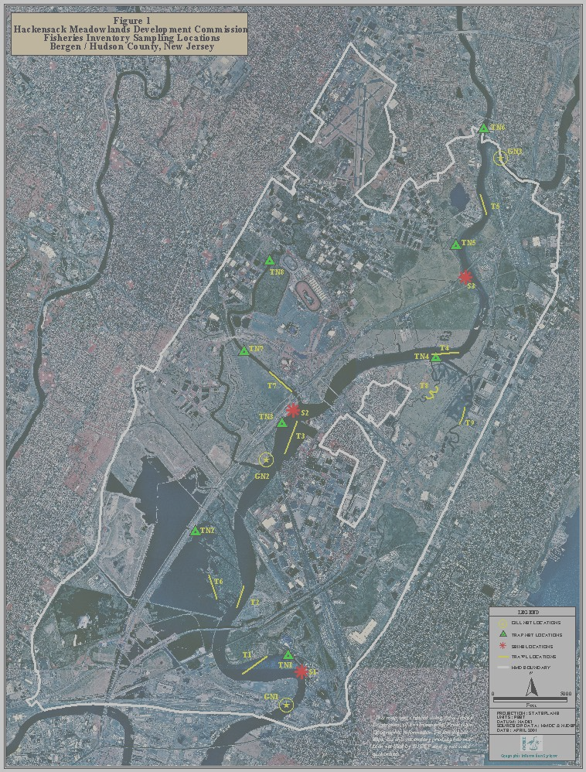
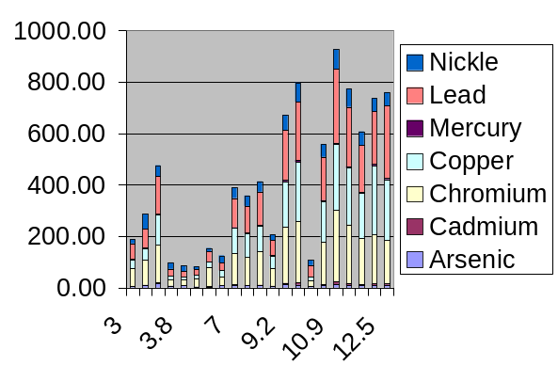

Figure 5. Visual Depiction of mercury spatial trend

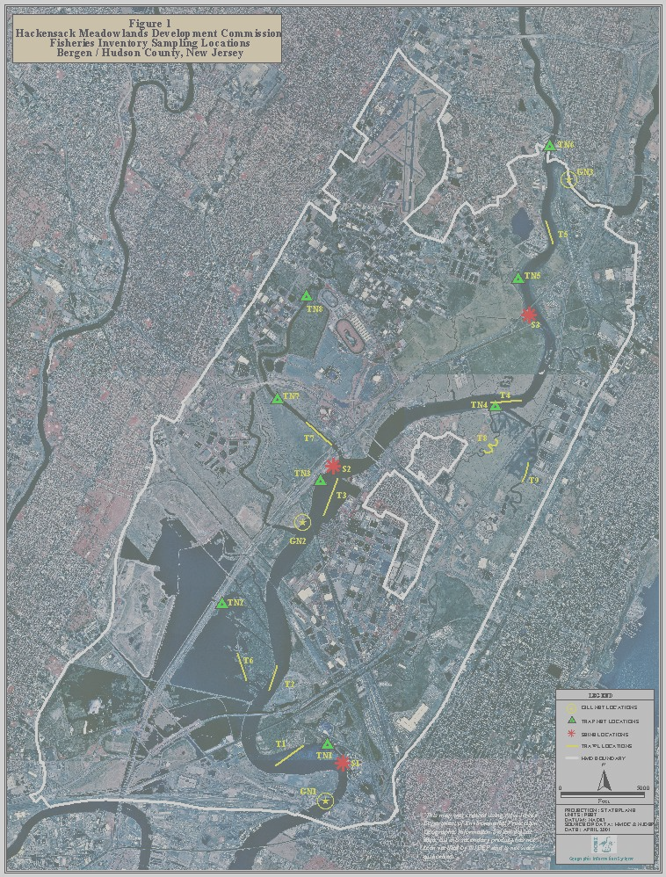

Sediment Metal Behavior
We can look to the relative concentration of total carbon and fine grained particles to discern why the metals reside where they do. Concentration distributions presented to show patterns of regional contaminant distributions and metal co-variances imply common sources or behaviors (Mecray et al 2001). Table 11 displays the Pearson product-moment coefficient (R²) which depicts the strength of the correlation of the values of independent variables obtained at each sampling site. With the exception of iron and arsenic, the sediment correlation matrix displays the close affinity of all of the metals. A general linear model was used to measure the relationship between each of the metals as independent or predictor variables and other metal as dependent or criterion variable (Filipiak and Johnson 2007). The significant model equations for each of the metals confirmed the strong interaction between the metals (Filipiak and Johnson 2007). Because correlation does not imply causation, it cannot be inferred from this information that the metals share a common source. It is more likely that their observed distributions result from the influence of hydrodynamics reflected by sediment texture and organic content.

Table 11. Sediment Correlation Matrix (R²)
Correlation coefficients > 0.77 are highlighted in yellow

 | Arsenic | Cadmium | Chromium | Copper | Iron | Lead | Mercury | Nickel | Zinc | River mile | % Fines
Cadmium | 0.47
Chromium | 0.58 | 0.93
Copper | 0.50 | 0.91 | 0.92
Iron | 0.63 | 0.55 | 0.63 | 0.66
Lead | 0.56 | 0.91 | 0.94 | 0.96 | 0.65
Mercury | 0.43 | 0.89 | 0.93 | 0.88 | 0.60 | 0.90
Nickel | 0.67 | 0.80 | 0.87 | 0.78 | 0.83 | 0.82 | 0.76
Zinc | 0.47 | 0.94 | 0.93 | 0.99 | 0.65 | 0.97 | 0.89 | 0.80
River mile | 0.13 | 0.77 | 0.71 | 0.85 | 0.62 | 0.79 | 0.81 | 0.60 | 0.85
% Fines | 0.55 | 0.54 | 0.54 | 0.65 | 0.70 | 0.62 | 0.58 | 0.47 | 0.63 | 0.61
% TOC | 0.62 | 0.85 | 0.89 | 0.92 | 0.79 | 0.95 | 0.87 | 0.82 | 0.92 | 0.80 | 0.79

Particulate size and resulting total surface area available for adsorption are both important factors in adsorption processes… smaller particles can both be more widely dispersed by water and can also serve as sites of enhanced adsorption (John and Leventhal 1995 p. 13). In this estuary dominated by the tidal regime, depositional environments occur when energy dissipates. One would expect the percent of fine material to increase as the distance increases from the mouth of the river; a moderate correlation (R² = 0.61) between % fines (silt and clay fraction) and river mile does exist. The strength of the correlation between the metals and % fines is moderate as well (average R² = 0.59). A confounding factor which diminishes the strength of the river mile/ percent fines correlation relates to the differing substrate requirements for the four net-types used for sampling fish which provided the sites for sediment collections as well (Table 6).
A better predictor of metal concentrations in the sediments appears to be the amount of organic matter present in the sediments. In organic carbon-rich sediments, trapped interstitial fluids can commonly form a strongly reducing (anoxic) environment. The sediment samples in this study averaged almost 60% water. Low redox potential in this environment can promote sulfate reduction and sulfide mineral deposition. During diagenesis, much of the potentially toxic metals, such as arsenic, cadmium, copper, mercury, lead, and zinc, can form insoluble sulfides; a change to an oxidizing environment caused by disturbance of the sediment and exposure to the atmosphere or with the influx of oxygenated (sea) water can result in rapid reaction of this anoxic sediment and thereby release significant proportions of these metals (John and Leventhal 1995 p. 13). The sulfate/sulfide mechanism appears to effect metal concentrations, helping to explain the enrichment in the upper reaches of the river and depletion as oxygenated sea water interacts the organic matter in sediments.

1988/2003 Comparison
Between 1988 and 2003, the average sediment concentration of cadmium, chromium, copper, lead and nickel was reduced by between 22% and 71%; zinc concentrations remained relatively constant (8% increase). This dramatic improvement suggests a natural attenuation process is burying contaminated sediments with cleaner material. Perhaps the naturally high background concentration of zinc found in this region provides a continuous supply of this metal to the sediments.

Table 12. Metal Comparison 1988/2003

Average Metal Concentrations (mg/kg)
Metal | 1988 | 2003 | Difference
Cadmium | 10.5 | 3.0 | -71%
Chromium | 347 | 130 | -63%
Copper | 429 | 115 | -73%
Lead | 164 | 128 | -22%
Nickel | 110 | 42.9 | -61%
Zinc | 243 | 263 | +8%

Statistical analysis was performed on the sediment metal concentrations as well (Filipiak, K. and Johnson, K., 2007). Three sites, S1, S3 and TN5, were not included in the year to year comparison. S3 was excluded because there was no data in 1988; it had been identified as S4. S1 and TN5 were excluded as the site identification was recorded incorrectly. To test whether there were significant different between studies done in 1987-88 and 2003 a paired t test was used. The justification for using the paired t experimental design was the methodology of having samples collected at approximately the same geographical locations where the only factor is the time in between collections (Filipiak, K. and Johnson, K., 2007).

Significant difference in concentrations was found for the following metals in sediments when comparing 1987-88 and 2003 using a paired t-test:
- Cadmium (Cd), levels higher for 1987-88
- Chromium (Cr), levels higher for 1987-88
- Copper (Cu), higher for 1987-88
- Lead (Pb), higher for 1987-88.

When the sites were grouped according to their location in the main river or tributaries, the following metals exhibited significant differences in the main river:
- Cadmium (Cd), higher for 1987-88
- Copper (Cu), higher for 1987-88
- Lead (Pb), higher for 1987-88

The main river levels of Chromium, Nickel and Zinc did not have a statistically significant change between 1987-88 and 2003. In the tributaries, there were no significant differences for any of the metals studied.

Statistics were also applied to the Lower, Middle and Upper segments of the Hackensack River (see Table 1 and Figure 1). The only statistically significant result was the higher value of cadmium concentrations in the Lower River in 1987-88 compared to 2003.

Organic Contaminants

In addition to expressing concentrations on a compound- or congener-specific basis, total
PCBs (t-PCBs), or the sum of all quantified PCB congeners, were calculated (Table 13).
Although individual compounds of DDT and its metabolites were reported, values for
DDXs were tabulated as well. DDXs are comprised of the two isomers (p,p and o,p) of DDT (1,1,1-trichloro-2,2-bis-(p-chlorophenyl)ethane), which was widely used to control insect pests on agricultural crops and those carrying infectious diseases, and the two isomers (p,p and o,p) of each of its metabolites, DDE (1,1-dichloro-2,2-bis(pchlorophenyl) ethylene)and DDD (1,1-dichloro-2, 2-bis(p-chlorophenyl) ethane). Like DDXs, a value for chlordane or “total chlordanes” was calculated (Table 13). In the U.S., chlordane was used as a pesticide on crops such as corn and citrus and on home lawns and gardens from 1948 to 1988. Chlordane is comprised of pure chlordane (cis and trans isomers) as well as many related chemicals (cis- and trans-nonachlor, oxychlordane, alpha-, beta- and gamma-chlordene, and chlordene). Total chlordanes (referred to herewithin as simply ‘chlordanes’) were defined as the sum of concentrations of heptachlor, heptachlor expoxide, oxychlordane, gamma chlordane, alpha chlordane, cis-nonachlor and trans-nonachlor. Other organochlorine pesticides were analyzed in sediment. Aldrin and dieldrin, both chlorinated cyclodiene insecticides, were popular pesticides for agricultural crops such as corn and cotton in the 1950s-1970. Aldrin breaks down into dieldrin in the environment. The Environmental Protection Agency banned all uses of dieldrin and aldrin in 1974 with the exception of termite control. In 1987, the agency banned all uses. Because dieldrin and aldrin are so closely related both in structure and toxicity, they are reported and regulated together. Aldrin and Dieldrin concentrations were low for all sediment, ranging from 0.04 to 14.22 ng/g. Alpha and beta forms of endosulfan (or I and II) make up the technical form of the insecticide endosulfan, was used to control insects on grains, tea, fruit, and vegetables though the majority of applications were made to tobacco and cotton. Though the pesticide has not been produced in the US since 1982, it is still currently used on crops and is used to produce other chemicals. Concentrations of total endosulfan (I and II) were very low for all sediments, ranging from 0.52 to 36.23 ng/g (Ashley et al., 2004).

Table 13. Total PCBs, DDXs Chlordanes (ng/g dry weight)

Site Location  And Replicate  Analyzed | PCBs | DDXs | Chlordanes
TN1 3 | 454 | 171 | 10
TN2 1 | 281 | 124 | 12
TN3 1 | 504 | 176 | 15
TN4 1 | 734 | 134 | 19
TN5 2 | 699 | 215 | 29
TN6 3 | 27 | 8 | 1

Figure 6. Congener specific PCB concentrations
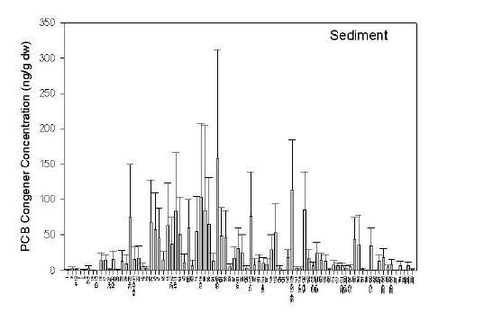

Congener-specific PCB profiles were plotted using mean concentrations (showing respective standard deviations) for sediment samples over all collections sites (Figure 6). For sediment, dominant single or coeluting congeners were 31+28, 41+71, 70+76, 66, 56+60, 77+110, 153+132+105, 163+138. These represent dominant congeners in Aroclor mixtures (Ashley et al., 2004).
Figure 7. Mean abundances of PCBs by Homologue Group
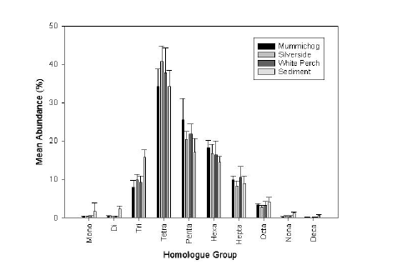

By normalizing each single or coeluting congener concentration to the t-PCB value, a normalized concentration or mean abundance (%) results. Normalization facilitates comparisons between sample types (e.g., biota and sediment). Expressing normalized concentrations on a homologue basis further aids in pattern recognition for differences and similarities by reducing the amount of data. The normalized homologue concentrations for white perch, mummichog, silverside, and sediment show remarkable similarity (Figure 7). Homologue patterns of fish that are reflective of sediments may denote a tight coupling between fish prey and sediment. Based on the similarities of patterns between fish and sediment, there is no evidence of preferential uptake, elimination, or degradation of certain congeners (Ashley et al., 2004).

Figure 8. Total PCB, DDX and Chlordane Concentrations (ng/g)
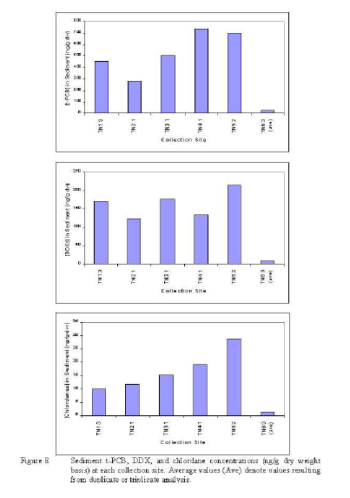

Sediment samples for organics analysis were collected along a relatively broad gradient along the Hackensack River and one of its tributaries. Sediment samples from six sites ranged in t-PCBs from
25 (site TN6 3) to 734 (site TN4 1) ng/g dw (Figure 8a), suggesting significant spatial variation in organic contaminant inventories within the sediments. Variations in sediment concentrations are likely reflective of variations in the magnitude of t-PCBs and other organochlorinated compounds being delivered to the sediments rather than being solely driven by grain size and organic carbon content. DDXs and chlordanes concentrations within the six sediment samples were lower than t-PCBs, ranging from from 22 (site TN6 3) to 699 (site TN5 2) ng/g dw (Figure 8b) and from 2 (site TN6 3) to 29 (site TN5 2) ng/g dw (Figure 8c), respectively. With the exception of one site (TN4 1), trends in t-PCB concentrations mirrored those seen in DDXs. Chlordanes steadily increased in concentration from TN sites 1 to 5; site TN6 had the lowest concentration with respect to all contaminants (Ashley et al., 2004).
Conclusions

Sampling and analytical methods applied to the sediment study of 2003 successfully replicated the 1988 effort, allowing for spatial and temporal comparisons between physical and chemical properties. The ecological quality of the Hackensack River Estuary was discerned using guidance criteria applied to metal concentrations.

The texture of bottom sediments has not changed greatly during the 15 year interval between studies and the sediment quality has clearly improved. Between 1988 and 2003, the average sediment concentration of cadmium, chromium, copper, lead and nickel was reduced by between 22% and 71%. However, since 60% of the sampling sites exceed more than five ERLs the estuary continues to exhibit metal contamination. An analysis of organic contaminants on a limited number of samples suggests that organic pollution is present. Concentrations of U.S. banned pesticides such Endosulfan, Aldrin and Dieldrin were low in all samples. .

Mercury concentrations once thought to be confined to Berry’s Creek, have now reached all parts of the estuary. Since Mercury was not determined in the 1989 study, it was not possible to determine trends over time.

Finally, the majority of the metals seem to be correlated. This correlation however does not conclusively show that they share a common source. The study indicates that their observed distributions are also closely related to sediment texture and organic content.

References

Ashley, J., Zaoudeh, L., and Velinsky, D J., 2004. Polychlorinated Biphenyl and Organochlorine Pesticide Concentrations in White Perch, Killifish and Sediment from the Lower Hackensack River and its Tributaries (Draft Final Report), Patrick Center for Environmental Research, The Academy of Natural Sciences, Philadelphia, PA 19103.

ASTM International, 2003. Standard Test Method for Particle-Size Analysis of Soils, D422-63(2002).

Bragin, A. B., Misuik, J., Woolcott, C. A., Barrett, K. R, and Jusino-Atresino, R. 2005. A Fishery Resource Inventory Of The Lower Hackensack River Within The Hackensack Meadowlands District A Comparative Study 2001-2003 vs. 1987-1988. New Jersey Meadowlands Commission, Meadowlands Environmental Research Institute, Lyndhurst, NJ 07071.

Filipiak, Karolina A., and Johnson, K., 2007. Analysis of the Sediment Data from the Lower Hackensack River, Abstract and presentation to the 2007 Meadowlands Symposium, New Jersey Meadowlands Commission, Meadowlands Environmental Research Institute, Lyndhurst, NJ 07071.

Frasco, Barry, 1997. Memorandum: Present use of draft 1991 NJDEP guidance for sediment quality evaluations, October 1997 update.

Goeller, A. F. III, 1989 Heavy metals and radionuclides in sediments of the Hackensack River, New Jersey. Master of Science Thesis, Rutgers University, Newark, New Jersey.

HMDC. 1989. Inventory of Fishery Resources of the Hackensack River within the jurisdictional
Boundary of the Hackensack Meadowlands Development Commission from Kearny, Hudson County, to Ridgefield, Bergen County, New Jersey.

John, David A and Joel S. Leventhal, 1995. BIOAVAILABILITY OF METALS. Ch. 2 in: Preliminary compilation of descriptive geoenvironmental mineral deposit models Edward A. du Bray, Editor. U.S. DEPARTMENT OF THE INTERIOR U.S. GEOLOGICAL SURVEY Open-File Report 95-831, Denver, Colorado.

Long, E.R., D.D. MacDonald, S.L. Smith, and F.D. Calder, 1995. Incidence of adverse biological effects within ranges of chemical concentrations in marine and estuarine sediments. Environmental Management 19(1):81–97.

Mecray, Ellen L., M. R. Buchholtz ten Brink, and S. Shah. 2001 Metal Distributions in the Surface Sediments of Long Island Sound. U.S. Department of the Interior, U.S. Geological Survey
URL: http://pubs.usgs.gov/of/2000/of00-304/htmldocs/chap06/index.htm in: Georeferenced Sea-Floor Mapping and Bottom Photography in Long Island Sound, Edited By Valerie F. Paskevich and
Lawrence J. Poppe.

United States Environmental Protection Agency, Office of Research and Development Office of Water, December 2004. National Coastal Condition Report II, Washington, DC 20460. EPA-620/R-03/002 http://www.epa.gov/owow/oceans/nccr2/.

United States Environmental Protection Agency Region 2 Superfund, VENTRON/VELSICOL, NEW JERSEY NPL Site Fact Sheet EPA ID# NJD980529879. http://www.epa.gov/region02/superfund/npl/0200674c.pdf Accessed 3/16/2006

Weis, Peddrick, 2005. Contaminants in Fish Of The Hackensack Meadowlands, NJMC Report, 28 pp.

Appendix 1
Grain-Size Analysis SOP

Standard Test Method for Particle-Size Analysis of Soils, D422-63(2002). ASTM International, 2003.
(Nicole Quinn, MERI)
Procedure:
- Expose the soil sample (about 130g out of jar for silt/clay soils, about 200g for sandy soils) to air at room temperature until dry. Use the blower under the hood. This could take 2-7 days.
- Break up aggregations in a mortar with a rubber-covered pestle, trying not to crush the grains.
- Sieve the ground sample through a No. 10 (2 mm) sieve using the Rotasift for 5 minutes.
- Break up aggregations retained on No. 10 sieve, using mortar and pestle. Sieve the ground material again through the No. 10 sieve for 5 minutes.
- After sieving the sample twice through the No. 10 sieve, remove the sieve and wash with DI/distilled water anything retained on the sieve. Put this sieve in the oven to dry at a temp. of 100 – 105 degrees Celsius. This is the coarse material.
- Get a 250mL beaker and a spatula and measure out 50g into the beaker for silt/clay soils and 100g for sandy soils. Use at least 32g for silt/clay and 82g for sandy soils. Use the PB3002-S DeltaRange scale.
- Add 125mL of the dispersing solution (40g/L sodium hexametaphosphate) to the beaker and stir until homogenized. Cover with parafilm, label, and leave for at least 16 hours.
- To make more dispersing solution, measure 40g of sodium hexametaphosphate and add to about 800mL DI/distilled water in a 1000mL beaker. Place on stir plate, and using stir bar, mix for about 20 minutes or until homogenized.
- Remove the sieve with the coarse material from oven when the sample is dry and sieve it for 5 minutes through both a No. 10 and a No. 4 sieve, simultaneously. Weigh and record the masses for each sieve. These are the masses of coarse material for the sample. Use the PB221S Sartorius scale.
- After 16 hours, begin the hydrometer readings for the samples. Use the same 151H hydrometer that was used throughout this project, for which a composite correction has already been made.
- Transfer soil-water slurry (sample in dispersing agent) from its beaker into a glass sedimentation cylinder and fill to 1000mL with DI/distilled water. Rinse all soil from beaker into cylinder. Label the cylinders. Only two tests can be run at a time, and it is possible to finish four in a day.
- Use a rubber stopper to cap the cylinder. Record both hydrometer (specific gravity) and temperature readings at intervals of 2, 5, 15, 30, 60, and 150 minutes after sedimentation begins. Hold both ends of the cylinder and mix for one minute. Setting down the cylinder is the beginning of sedimentation. Record your start time.
- When you have finished the hydrometer/temp readings for the sample, pour the cylinder through a No. 230 (63 um) sieve over the sink and run tap water though it until clear. Dry the material retained on the No. 230 sieve in an aluminum weighing dish in the oven at 105 degrees Celsius. This will take about 1.5 – 2 days for most samples to completely dry.
- Once dried, break up aggregations in mortar with rubber-covered pestle. Perform a final sieve analysis of the material through a No. 40 (425 um), No. 60 (250 um), and a No. 120 (125 um) sieve (simultaneously) for 20 minutes. Weigh (on the Sartorius scale) and record the mass of material retained on each sieve and the material that passed through all three sieves. This is the mass of sandy material.

Appendix 2 Grain-Size Calculator

 | PARTICLE-SIZE ANALYSIS OF SOILS ASTM D 422
 | Start by recording data from notebook or worksheet.
 | Hit [F9] to calculate.
 | Save to a new file name and repeat.
 |  | Sample # | 78816
 |  | Location | GN2-3
 |  | Weight (g) | 50.0
 |  | Temperature C | 21.0
 |  | K | 0.014
Sieve Analysis |  |  |  | Size Classification and %
Sieve | Weight (g) |  |  | Pebble | 0.00%
4 | 0.000 |  |  | Granule | 0.25%
10 | 0.124 |  |  | Coarse Sand | 0.00%
40 | 0.000 |  |  | Medium Sand | 5.36%
60 | 2.681 |  |  | Fine Sand | 4.03%
120 | 2.013 |  |  | Very Fine Sand | 0.00%
230 | 0.000 |  |  | Silt | 62.6%
<230 | 45.18 |  |  | Clay | 27.8%
 |  | Hydrometer Analysis
Time (T) | Hydrometer reading | % in Suspension | Depth L | L/T | Diameter (D) | Ln D
2 | 1.020 | 65.0% | 11.0 | 5.500 | 0.032 | -3.439
5 | 1.017 | 55.2% | 11.8 | 2.360 | 0.021 | -3.862
15 | 1.014 | 45.5% | 12.6 | 0.840 | 0.013 | -4.378
30 | 1.012 | 39.0% | 13.1 | 0.437 | 0.009 | -4.705
60 | 1.011 | 35.7% | 13.4 | 0.223 | 0.006 | -5.041
150 | 1.009 | 29.2% | 13.9 | 0.093 | 0.004 | -5.480
 |  | Silt diameter | Ln |  | Trend Coefficient
 |  | 0.005 | -5.298 |  | 0.308

Appendix 3
Sediment Sample Textures 2003

Location | Pebble 4 MM | Granule 2 MM | Coarse Sand 0.5 MM | Medium Sand 0.25 MM | Fine Sand 0.125 MM | Very Fine Sand 0.0625 MM | Silt 0.005 MM | Clay < 0.005 MM
TN1-1 | 0.72% | 0.31% | 0.96% | 1.37% | 0.03% | 21.0% | 33.3% | 42.4%
TN1-2 | 0.34% | 0.71% | 0.00% | 0.00% | 0.00% | 0.00% | 47.5% | 51.4%
TN1-3 | 0.00% | 0.33% | 0.45% | 2.07% | 0.03% | 20.8% | 38.0% | 38.3%
S1-1 | 16.4% | 11.3% | 33.8% | 17.5% | 0.01% | 18.2% | 1.76% | 1.01%
S1-2 | 29.5% | 12.1% | 31.3% | 9.21% | 0.06% | 17.4% | 0.31% | 0.18%
S1-3 | 21.7% | 19.4% | 17.1% | 9.78% | 0.02% | 29.6% | 1.31% | 1.06%
GN1-1 | 0.02% | 0.50% | 1.50% | 12.9% | 15.9% | 50.6% | 9.15% | 9.54%
GN1-2 | 1.13% | 1.07% | 2.51% | 13.6% | 0.01% | 65.1% | 9.87% | 6.65%
GN1-3 | 0.05% | 0.67% | 2.92% | 12.8% | 0.01% | 61.4% | 12.0% | 10.2%
T1-1 Deep | 6.85% | 2.11% | 1.17% | 3.68% | 0.02% | 35.4% | 25.8% | 24.9%
T1-2 Deep | 0.00% | 0.00% | 0.46% | 1.97% | 0.01% | 25.4% | 21.4% | 50.8%
T1-3 Deep | 0.00% | 0.00% | 2.95% | 3.29% | 5.00% | 0.0% | 42.3% | 46.5%
T1-1 Shallow | 0.00% | 0.00% | 0.36% | 2.46% | 0.03% | 11.9% | 26.3% | 58.9%
T1-2 Shallow | 1.01% | 2.52% | 3.29% | 2.33% | 0.06% | 15.5% | 28.5% | 46.7%
T1-3 Shallow | 7.41% | 2.15% | 3.22% | 3.46% | 0.02% | 20.5% | 23.3% | 40.0%
TN2-1 | 0.00% | 0.06% | 1.17% | 1.93% | 3.06% | 13.0% | 29.6% | 51.3%
TN2-2 | 0.00% | 0.04% | 0.17% | 0.36% | 0.00% | 4.39% | 35.2% | 59.9%
TN2-3 | 0.00% | 0.15% | 0.72% | 1.40% | 0.09% | 14.1% | 25.2% | 58.3%
S2-1 | 13.3% | 5.55% | 6.26% | 10.2% | 0.04% | 23.6% | 22.2% | 18.9%
S2-2 | 27.4% | 8.64% | 0.00% | 27.0% | 18.8% | 12.2% | 3.4% | 2.62%
S2-3 | 27.4% | 8.14% | 8.22% | 5.85% | 1.53% | 12.9% | 12.1% | 23.9%
GN2-1 | 5.43% | 0.70% | 1.42% | 8.90% | 0.03% | 17.4% | 21.3% | 44.8%
GN2-2 | 0.00% | 0.35% | 0.61% | 3.45% | 0.02% | 30.9% | 27.8% | 36.9%
GN2-3 | 0.00% | 0.25% | 0.00% | 5.36% | 4.03% | 0.00% | 23.9% | 66.4%
T2-1 Deep | 11.9% | 1.89% | 10.2% | 26.7% | 0.01% | 49.1% | 0.17% | 0.07%
T2-2 Deep | 4.07% | 2.55% | 9.79% | 12.7% | 0.02% | 16.8% | 42.2% | 11.9%
T2-3 Deep | 3.69% | 1.87% | 21.9% | 30.4% | 0.05% | 38.0% | 3.17% | 0.88%
T2-1 Shallow | 0.11% | 0.51% | 8.30% | 2.39% | 0.01% | 83.7% | 3.6% | 1.44%
T2-2 Shallow | 2.48% | 0.75% | 0.55% | 2.10% | 0.01% | 69.4% | 16.8% | 7.92%
T2-3 Shallow | 0.00% | 0.01% | 1.64% | 2.56% | 0.02% | 86.5% | 8.22% | 1.10%
TN3-1 | 0.00% | 0.07% | 12.3% | 9.87% | 6.94% | 21.0% | 28.2% | 21.5%
TN3-2 | 0.60% | 0.02% | 0.36% | 0.37% | 0.00% | 5.29% | 31.7% | 61.7%
TN3-3 | 0.99% | 0.17% | 0.37% | 0.38% | 0.00% | 5.43% | 15.8% | 76.9%
S3-1 | 0.00% | 0.30% | 0.42% | 1.02% | 0.01% | 3.34% | 18.7% | 76.2%
S3-2 | 0.07% | 0.56% | 1.39% | 2.76% | 0.01% | 6.03% | 31.9% | 57.3%
S3-3 | 0.00% | 0.48% | 1.24% | 2.92% | 0.03% | 5.57% | 25.5% | 64.2%
GN3-1 | 0.00% | 0.00% | 11.6% | 0.79% | 0.05% | 1.66% | 45.7% | 40.2%
GN3-2 | 0.00% | 0.18% | 3.22% | 0.64% | 0.00% | 1.55% | 51.0% | 43.4%
GN3-3 | 0.00% | 0.00% | 7.02% | 1.10% | 0.04% | 5.25% | 42.1% | 44.4%
T3-1 Deep | 0.00% | 0.00% | 2.21% | 3.22% | 0.08% | 17.4% | 20.1% | 57.0%
T3-2 Deep | 0.00% | 0.29% | 0.27% | 0.29% | 0.00% | 6.47% | 26.8% | 65.9%
T3-3 Deep | 0.22% | 0.07% | 0.19% | 0.33% | 0.02% | 6.55% | 22.7% | 69.9%
T3-1 Shallow | 0.00% | 12.6% | 0.16% | 0.39% | 0.03% | 6.04% | 25.4% | 55.4%
T3-2 Shallow | 0.00% | 0.14% | 0.26% | 0.42% | 0.02% | 7.15% | 27.3% | 64.7%
T3-3 Shallow | 0.00% | 0.00% | 1.50% | 3.88% | 0.03% | 23.7% | 28.4% | 42.6%
TN4-1 | 0.00% | 0.01% | 1.76% | 0.87% | 0.02% | 4.31% | 26.3% | 66.8%
TN4-2 | 0.00% | 0.02% | 13.7% | 0.84% | 0.23% | 4.08% | 27.1% | 54.0%
TN4-3 | 0.00% | 0.00% | 3.74% | 8.69% | 0.07% | 31.5% | 19.7% | 36.3%
T4-1 Deep | 0.00% | 0.18% | 0.19% | 1.53% | 0.03% | 36.6% | 24.9% | 36.6%
T4-2 Deep | 0.00% | 0.13% | 1.90% | 2.23% | 0.04% | 46.7% | 22.1% | 26.9%
T4-3 Deep | 0.19% | 0.05% | 0.22% | 1.95% | 0.02% | 25.5% | 30.2% | 41.8%
T4-1 Shallow | 0.00% | 0.00% | 5.41% | 8.22% | 0.06% | 30.2% | 14.0% | 42.1%
T4-2 Shallow | 0.00% | 0.11% | 3.04% | 0.98% | 0.01% | 4.83% | 32.0% | 59.0%
T4-3 Shallow | 0.00% | 0.00% | 8.01% | 6.98% | 0.08% | 26.3% | 18.6% | 40.1%
TN5-1 | 0.00% | 0.00% | 9.64% | 6.26% | 0.13% | 26.9% | 18.6% | 38.4%
TN5-2 | 0.00% | 0.00% | 0.00% | 8.85% | 2.07% | 0.00% | 23.8% | 65.3%
TN5-3 | 0.00% | 0.07% | 3.68% | 1.84% | 0.47% | 0.00% | 34.4% | 59.6%
T5-1 Deep | 0.00% | 0.00% | 5.14% | 1.02% | 0.01% | 5.10% | 45.0% | 43.7%
T5-2 Deep | 0.00% | 0.06% | 1.10% | 1.12% | 0.01% | 8.29% | 34.8% | 54.6%
T5-3 Deep | 0.00% | 0.21% | 4.45% | 2.81% | 0.09% | 16.6% | 28.1% | 47.8%
T5-1 Shallow | 0.00% | 1.95% | 1.46% | 1.68% | 0.17% | 6.93% | 41.6% | 46.2%
T5-2 Shallow | 0.00% | 0.00% | 8.96% | 3.26% | 0.26% | 14.4% | 32.0% | 41.1%
T5-3 Shallow | 0.00% | 0.07% | 7.61% | 1.99% | 0.01% | 12.4% | 35.8% | 42.2%
TN6-1 | 1.47% | 0.08% | 9.00% | 2.38% | 0.02% | 6.80% | 35.1% | 45.2%
TN6-2 | 0.00% | 0.06% | 1.21% | 0.79% | 0.29% | 5.82% | 27.0% | 64.8%
TN6-3 | 0.01% | 0.25% | 3.14% | 4.04% | 0.24% | 7.54% | 41.1% | 43.7%
T6-1 | 0.00% | 0.96% | 6.29% | 4.34% | 1.76% | 0.00% | 22.9% | 63.7%
T6-2 | 2.98% | 1.90% | 6.82% | 10.1% | 0.02% | 20.3% | 20.3% | 37.5%
T6-3 | 0.00% | 0.06% | 0.03% | 2.04% | 0.02% | 12.4% | 11.5% | 74.0%
T7-1 | 0.00% | 0.04% | 4.77% | 0.92% | 0.01% | 5.24% | 41.7% | 47.4%
T7-2 | 1.52% | 5.12% | 9.30% | 2.31% | 0.02% | 7.78% | 46.7% | 27.3%
T7-3 | 0.56% | 0.53% | 2.23% | 1.04% | 0.33% | 4.47% | 37.7% | 53.1%
T8-1 | 2.38% | 4.07% | 2.44% | 1.37% | 0.04% | 5.10% | 40.2% | 44.4%
T8-2 | 0.08% | 1.03% | 1.40% | 1.74% | 0.01% | 8.56% | 31.7% | 55.4%
T8-3 | 3.34% | 4.53% | 4.38% | 2.14% | 0.47% | 4.91% | 51.0% | 29.3%
T9-1 | 0.02% | 0.07% | 5.73% | 2.43% | 0.01% | 6.64% | 53.6% | 31.5%
T9-2 | 0.19% | 0.15% | 2.72% | 1.85% | 0.01% | 5.91% | 44.4% | 44.8%
T9-3 | 0.00% | 0.14% | 4.26% | 2.10% | 0.02% | 8.70% | 43.7% | 41.1%

Appendix 4
Sediment Sample Textures (Percentage) 1988

Location | Pebble 4 MM | Granule 2 MM | Very Coarse Sand  1 MM | Coarse Sand  0.5 MM | Medium Sand  0.25 MM | Fine Sand 0.125 MM | Very Fine Sand  0.0625 MM | Silt and Clay  < 0.0625 MM
TN1 | 0 | 0.2 | 1.6 | 2.8 | 6.1 | 7.7 | 5.3 | 76.3
S1 | 8 | 6.4 | 6.2 | 10.4 | 12.8 | 12.2 | 4.6 | 39.4
GN1 | 0 | 0.3 | 0.3 | 0.7 | 22.2 | 58.5 | 6.5 | 11.5
T1 Deep | 3.6 | 3.7 | 1.7 | 2 | 5.9 | 16.2 | 11.8 | 55.1
T1 Shallow | 0.32 | 0.5 | 0.4 | 1.3 | 3.8 | 20.9 | 16.4 | 56.4
TN2 | 0 | 0.3 | 0.8 | 0 | 0.4 | 2.2 | 1.5 | 94.8
S2 | 0.7 | 1 | 2.2 | 4.4 | 8.8 | 24.4 | 18 | 40.3
GN2 | 0 | 0.7 | 0 | 0.8 | 10 | 8.6 | 6.7 | 73
T2 Deep | 0.1 | 1.9 | 2 | 10.1 | 27.8 | 30.8 | 9.8 | 17.6
T2 Shallow | 54.1 | 6.5 | 2.9 | 3.5 | 8.2 | 10.1 | 3.6 | 11
TN3 | 0 | 0.2 | 0.7 | 1.3 | 0.2 | 0.9 | 0.7 | 96
S3 | 0 | 0.1 | 0.5 | 0 | 0.2 | 1.3 | 0.5 | 97.3
GN3 | 0 | 0 | 0 | 0 | 0.2 | 0.1 | 1.5 | 98.2
T3 Deep | 0 | 0 | 0.8 | 0 | 0.1 | 1.6 | 4.7 | 92.8
T3 Shallow | 0 | 0.7 | 0.1 | 0 | 0.4 | 2.1 | 5.8 | 91
TN4 | 0 | 0.7 | 0.3 | 0 | 0 | 1.5 | 2.8 | 89.4
T4 Deep | 0 | 0 | 0.4 | 0 | 0.2 | 2.1 | 8.3 | 88.9
T4 Shallow | 0 | 0.7 | 0.3 | 0 | 0.1 | 1.7 | 3.3 | 93.9
TN5 | 0 | 0 | 0.7 | 0 | 1 | 14.8 | 5.8 | 77.6
T5 Deep | 0 | 0.3 | 3.5 | 7.9 | 29.8 | 38.3 | 5.4 | 14.8
T5 Shallow | 0 | 0.1 | 0 | 0 | 0.1 | 0.3 | 2.8 | 96.7
TN6 | 0 | 0.3 | 0.5 | 1.6 | 1 | 7.5 | 4.3 | 84.8
T6 | 0 | 0 | 0.6 | 0 | 0.5 | 2.1 | 2.1 | 94.8
T7 | 0 | 0.2 | 0.8 | 0.2 | 0.3 | 1.7 | 2.3 | 94.6
T8 | 0 | 0.1 | 0.3 | 0 | 0.4 | 5.8 | 2 | 91.4
T9 | 0 | 0.1 | 0.8 | 0.1 | 1 | 2.9 | 2.6 | 92.5

Note: Percentages reflect the results obtained from one sample collected at each location.
Appendix 5
Metal Concentrations of Sediments Collected in 2003 (mg/kg Dry Wt.)

 | Collection | T.O.C. | % Fines | METALS (ug/g) Dry Weight
Site - Rep. # | Date | (%) | (silt & clay) | As | Cd | Cr | Cu | Hg | Pb | Ni | Zn | Fe
T5 Shallow-1 | 7/11/03 | N.D. | 87.8 | 12.3 | 7.36 | 134 | 203 | 4.64 | 230 | 52.0 | 469 | 37348
T5 Shallow-2 | 7/22/03 | 13.7 | 73.1 | 13.3 | 11.7 | 316 | 294 | 5.84 | 306 | 95.9 | 738 | 35332
T5 Shallow-3 | 7/22/03 | 13.2 | 77.9 | 14.5 | 10.6 | 384 | 268 | 8.55 | 327 | 80.6 | 773 | 33892
T5 Deep-1 | 7/22/03 | 14.3 | 88.7 | 10.0 | 4.22 | 142 | 189 | 4.28 | 185 | 55.1 | 436 | 37593
T5 Deep-2 | 7/22/03 | 15.9 | 89.4 | 9.3 | 6.18 | 145 | 197 | 4.43 | 202 | 63.3 | 453 | 38317
T5 Deep-3 | 7/22/03 | 15.9 | 75.8 | 10.3 | 11.4 | 398 | 274 | 8.66 | 306 | 96.8 | 675 | 32193
GN3-1 | 8/5/03 | 13.1 | 85.9 | 9.1 | 5.24 | 190 | 258 | 4.85 | 144 | 50.2 | 521 | 39472
GN3-2 | 8/5/03 | 12.8 | 94.4 | 8.4 | 5.03 | 198 | 261 | 4.46 | 221 | 47.3 | 505 | 35780
GN3-3 | 8/5/03 | 11.8 | 86.6 | 11.4 | 5.63 | 183 | 289 | 4.69 | 250 | 56.1 | 555 | 38029
TN6-1 | 8/5/03 | 16.4 | 80.3 | 10.0 | 5.58 | 174 | 234 | 4.56 | 239 | 55.2 | 510 | 38999
TN6-2 | 8/5/03 | 15.8 | 91.8 | 10.1 | 4.94 | 173 | 243 | 4.55 | 241 | 49.0 | 516 | 38106
TN6-3 | 8/5/03 | 13.6 | 84.8 | 10.2 | 4.71 | 159 | 234 | 4.83 | 366 | 52.7 | 455 | 36209
TN1-1 | 8/5/03 | 9.39 | 75.6 | 11.9 | 1.39 | 124 | 101 | 2.49 | 125 | 38.3 | 196 | 28208
TN1-2 | 8/5/03 | 10.3 | 99.0 | 18.0 | 3.92 | 146 | 114 | 2.58 | 161 | 43.0 | 244 | 27904
TN1-3 | 8/5/03 | 10.7 | 76.3 | 21.4 | 2.13 | 166 | 140 | 2.63 | 158 | 43.9 | 251 | 31481
TN2-1 | 8/5/03 | 9.42 | 80.8 | 9.40 | 1.63 | 119 | 104 | 1.77 | 115 | 37.8 | 239 | 32867
TN2-2 | 8/5/03 | 10.2 | 95.0 | 9.30 | 2.52 | 127 | 106 | 2.31 | 136 | 46.2 | 243 | 31953
TN2-3 | 8/5/03 | 9.65 | 83.6 | 9.30 | 1.96 | 123 | 109 | 2.11 | 139 | 39.2 | 251 | 33632
GN1-1 | 12/4/03 | 2.17 | 18.7 | 4.85 | 0.83 | 62.9 | 35.4 | 1.43 | 52.7 | 16.5 | 98 | 13214
GN1-2 | 12/4/03 | 4.50 | 16.5 | 4.50 | 0.71 | 72.1 | 26.1 | 0.73 | 51.5 | 13.1 | 86 | 10119
GN1-3 | 12/4/03 | 5.54 | 22.1 | 6.04 | 0.88 | 71.8 | 40.2 | 1.19 | 80.5 | 19.0 | 118 | 14085
S1-1 | 12/4/03 | 3.71 | 2.77 | 10.7 | 0.29 | 118 | 36.4 | 0.30 | 54.1 | 71.9 | 91 | 35598
S1-2 | 12/4/03 | 4.76 | 0.49 | 11.2 | 0.43 | 80.6 | 45.7 | 1.28 | 76.9 | 42.0 | 116 | 39712
S1-3 | 12/4/03 | 8.15 | 2.37 | 9.2 | 0.54 | 89.9 | 57.8 | 0.98 | 90.2 | 59.6 | 133 | 28849
T6-1 | 12/4/03 | 6.04 | 86.7 | 6.11 | 0.14 | 24.1 | 13.1 | 0.10 | 25.4 | 28.1 | 71.2 | 30114
T6-2 | 12/4/03 | 4.86 | 57.8 | 6.37 | 0.09 | 17.0 | 11.2 | 0.45 | 15.2 | 19.6 | 50.0 | 22551
T6-3 | 12/4/03 | 6.09 | 85.4 | 6.59 | 0.16 | 27.1 | 15.8 | 0.05 | 24.1 | 29.7 | 76.1 | 35248
S2-1 | 12/4/03 | 5.35 | 41.1 | 7.23 | 1.03 | 97.5 | 65.2 | 2.81 | 81.4 | 30.1 | 175 | 24612
S2-2 | 12/4/03 | 4.41 | 5.98 | 3.98 | 0.67 | 46.0 | 30.0 | 2.06 | 39.6 | 15.7 | 89.1 | 14593
S2-3 | 12/4/03 | 4.66 | 36.0 | 5.84 | 0.99 | 63.7 | 47.0 | 3.72 | 52.8 | 21.5 | 126 | 20371
TN3-1 | 12/4/03 | 10.5 | 49.7 | 8.38 | 1.61 | 125 | 98.3 | 5.03 | 117 | 38.8 | 225 | 33847
TN3-2 | 12/4/03 | 7.04 | 93.4 | 9.06 | 1.62 | 127 | 100 | 3.36 | 143 | 40.3 | 241 | 34899
TN3-3 | 12/4/03 | 10.6 | 92.7 | 9.32 | 1.62 | 137 | 99.3 | 4.18 | 126 | 42.2 | 242 | 36088
TN5-1 | 12/12/03 | 12.5 | 57.0 | 9.01 | 4.27 | 184 | 183 | 4.47 | 189 | 56.8 | 401 | 36467
TN5-2 | 12/12/03 | 12.7 | 89.1 | 9.16 | 3.24 | 163 | 162 | 3.79 | 170 | 50.4 | 386 | 38544
TN5-3 | 12/12/03 | 12.7 | 93.9 | 9.15 | 4.18 | 187 | 181 | 4.79 | 187 | 54.3 | 363 | 35759
S3-1 | 12/12/03 | 12.5 | 94.9 | 9.79 | 3.01 | 179 | 157 | 5.11 | 177 | 49.6 | 373 | 37568
S3-2 | 12/12/03 | 12.7 | 89.2 | 9.33 | 3.31 | 158 | 169 | 4.32 | 163 | 51.0 | 347 | 36712
S3-3 | 12/12/03 | 12.8 | 89.8 | 9.79 | 2.52 | 159 | 147 | 3.66 | 163 | 49.2 | 356 | 37417
T4 Deep-1 | 12/12/03 | 6.52 | 61.5 | 6.28 | 0.20 | 19.7 | 13.1 | 0.11 | 27.6 | 22.2 | 58 | 24479
T4 Deep-2 | 12/12/03 | 5.74 | 49.0 | 7.90 | 0.18 | 19.8 | 12.9 | 0.15 | 30.5 | 17.0 | 54 | 26222
T4Deep-3 | 12/12/03 | 6.89 | 72.1 | 3.18 | 0.71 | 24.6 | 15.5 | 0.02 | 77.7 | 21.5 | 71 | 24260
T4 Shallow-1 | 12/12/03 | 13.0 | 56.1 | 10.7 | 8.01 | 241 | 248 | 9.58 | 232 | 74.6 | 426 | 39234
T4 Shallow-2 | 12/12/03 | 11.9 | 91.0 | 11.6 | 8.87 | 226 | 210 | 8.69 | 223 | 75.3 | 451 | 37175
T4Shallow-3 | 12/12/03 | 13.5 | 58.6 | 11.1 | 8.41 | 253 | 225 | 7.66 | 225 | 72.8 | 434 | 38090
TN4-1 | 12/12/03 | 13.6 | 93.0 | 11.7 | 5.38 | 214 | 185 | 5.23 | 187 | 60.2 | 396 | 37472
TN4-2 | 12/12/03 | 15.1 | 81.2 | 12.4 | 6.49 | 224 | 180 | 6.24 | 199 | 62.0 | 396 | 39010
TN4-3 | 12/12/03 | 11.1 | 56.0 | 11.2 | 5.97 | 217 | 165 | 6.49 | 193 | 57.1 | 377 | 33579
T1 Shallow-1 | 12/18/03 | 7.10 | 85.2 | 8.80 | 0.10 | 22.4 | 13.8 | 0.06 | 22.1 | 26.8 | 63.5 | 29156
T1 Shallow-2 | 12/18/03 | 5.10 | 75.3 | 6.71 | 0.20 | 27.2 | 16.3 | 0.16 | 36.4 | 25.6 | 64.6 | 24839
T1 Shallow-3 | 12/18/03 | 8.50 | 63.3 | 5.51 | 0.14 | 20.0 | 13.4 | 0.05 | 23.5 | 23.0 | 49.5 | 25396
T1 Deep-1 | 12/18/03 | 6.79 | 50.7 | 8.89 | 0.11 | 18.8 | 12.4 | 0.13 | 25.3 | 21.7 | 48.1 | 28642
T1 Deep-2 | 12/18/03 | 6.01 | 72.2 | 8.02 | 0.12 | 20.7 | 9.66 | 0.00 | 20.9 | 25.5 | 61.0 | 27684
T1 Deep-3 | 12/18/03 | 4.00 | 88.8 | 9.38 | 0.17 | 22.4 | 11.5 | 0.03 | 21.8 | 20.6 | 59.9 | 26087
T2 Shallow-1 | 12/18/03 | 2.48 | 5.03 | 3.44 | 0.30 | 34.9 | 10.9 | 0.20 | 14.9 | 10.3 | 52.6 | 11720
T2 Shallow-2 | 12/18/03 | 2.00 | 24.7 | 3.85 | 0.20 | 31.6 | 11.0 | 0.21 | 25.9 | 10.8 | 57.5 | 12256
T2Shallow-3 | 12/18/03 | 2.60 | 91.0 | 3.74 | 0.35 | 30.7 | 13.4 | 0.19 | 27.4 | 11.3 | 54.0 | 12015
T2 Deep-1 | 12/18/03 | 2.61 | 0.25 | 3.79 | 0.43 | 83.8 | 17.1 | 0.40 | 24.6 | 13.1 | 66.9 | 12197
T2 Deep-2 | 12/18/03 | 2.63 | 54.1 | 3.30 | 0.34 | 45.0 | 15.2 | 0.35 | 48.9 | 11.7 | 52.8 | 9580
T2 Deep-3 | 12/18/03 | 1.92 | 4.06 | 3.64 | 0.63 | 99.3 | 26.2 | 0.55 | 44.6 | 17.2 | 86.0 | 14639
T3 Shallow-1 | 12/18/03 | 9.05 | 80.8 | 9.41 | 1.68 | 113 | 96.6 | 2.53 | 111 | 42.6 | 206 | 35249
T3 Shallow-2 | 12/18/03 | 10.2 | 92.0 | 9.18 | 1.74 | 127 | 103 | 2.74 | 115 | 42.1 | 214 | 33548
T3 Shallow-3 | 12/18/03 | 10.6 | 70.9 | 10.3 | 1.65 | 124 | 97.8 | 2.69 | 114 | 41.1 | 220 | 33101
T3 Deep-1 | 12/18/03 | 10.4 | 77.1 | 8.47 | 1.29 | 109 | 97.3 | 1.83 | 104 | 40.2 | 224 | 30968
T3 Deep-2 | 12/18/03 | 10.2 | 92.7 | 7.62 | 1.46 | 104 | 88.6 | 2.29 | 99.2 | 38.6 | 197 | 28276
T3 Deep-3 | 12/18/03 | 9.88 | 92.6 | 8.39 | 1.60 | 111 | 91.5 | 2.56 | 112 | 41.9 | 208 | 32010
GN2-1 | 12/29/03 | 7.03 | 66.1 | 9.36 | 0.45 | 41.7 | 33.7 | 0.55 | 35.0 | 31.3 | 98.3 | 37439
GN2-2 | 12/29/03 | 4.78 | 64.6 | 10.1 | 0.27 | 23.7 | 17.2 | 0.30 | 25.4 | 29.1 | 76.7 | 34499
GN2-3 | 12/29/03 | 5.12 | 90.4 | 5.38 | 0.31 | 34.4 | 23.9 | 0.30 | 27.0 | 23.9 | 71.0 | 31598
T7-1 | 12/29/03 | 9.09 | 89.0 | 13.9 | 11.57 | 308 | 240 | 15.09 | 234 | 73.2 | 519 | 35445
T7-2 | 12/29/03 | 19.0 | 74.0 | 14.2 | 13.70 | 287 | 224 | 25.24 | 215 | 72.6 | 535 | 45747
T7-3 | 12/29/03 | 12.5 | 90.8 | 13.3 | 13.88 | 296 | 247 | 22.19 | 231 | 74.4 | 554 | 32987
T8-1 | 12/29/03 | 21.0 | 84.6 | 11.4 | 1.98 | 168 | 136 | 3.53 | 138 | 50.4 | 289 | 39307
T8-2 | 12/29/03 | 15.6 | 87.2 | 1.30 | 1.45 | 160 | 130 | 2.65 | 136 | 52.7 | 276 | 36831
T8-3 | 12/29/03 | 20.4 | 80.2 | 55.6 | 2.35 | 181 | 133 | 4.04 | 149 | 53.5 | 283 | 40390
T9-1 | 12/29/03 | 16.4 | 85.1 | 12.0 | 2.04 | 158 | 144 | 3.08 | 162 | 53.0 | 328 | 39216
T9-2 | 12/29/03 | 16.5 | 89.2 | 11.2 | 1.97 | 159 | 149 | 3.33 | 144 | 50.6 | 271 | 46105
T9-3 | 12/29/03 | 16.1 | 84.8 | 11.5 | 2.56 | 157 | 145 | 3.44 | 152 | 51.0 | 337 | 35251
 | MIN | 1.92 | 0.25 | 1.30 | 0.09 | 17 | 10 | 0.00 | 15 | 10.3 | 48 | 9580
 | MAX | 21.01 | 99.0 | 55.6 | 13.9 | 398 | 294 | 25.2 | 366 | 96.8 | 773 | 46105
 | AVG | 9.78 | 68.9 | 9.64 | 3.05 | 130 | 115 | 3.55 | 128 | 42.9 | 263 | 31095
 | ST DEV | 4.69 | 28.1 | 6.26 | 3.47 | 87 | 88 | 4.30 | 86 | 20.3 | 185 | 8756
* The T.O.C. values shown are the mean of two samples.
+ The T.O.C. value shown is the mean of three samples.

Appendix 6
Metal Concentrations of Sediments Collected in 1988 (mg/kg Dry Wt.)

Sample | N | Ni | Cu | Pb | Cd | Zn | Cr
T1 (shallow) | 4 | 37.3 ± 4.3 | 176 ± 10.8 | 151.3 ± 39.8 | 2.8 ± 0.5 | 140.5a | 256.5 ± 26.1
T1 (deep) | 2 | 49.5 | 371 | 28.5 | 1.7 | 114b | 35
T2 (shallow) | 2 | 86.5 | 1128.5 | 101 | 2.9 | 367b | 71
T2 (deep) | 2 | 127.5 | 836.5 | 196 | 3.7 | 402b | 251
T3 (shallow) | 2 | 22.5 | 121.5 | 116.5 | 2.9 | 96b | 115
T3 (deep) | 2 | 38 | 163.5 | 119.5 | 3.8 | 112b | 145.5
T4 (shallow) | 3 | 61.7 ± 2.4 | 303 ± 11.5 | 235.3 ± 46.5 | 8.9 ± 0.7 | 225b | 430.3 ± 95.1
T4 (deep) | 3 | 60.3 ± 6.3 | 271 ± 9.9 | 219.7 ± 25.2 | 8.0 ± 1.1 | 180a | 302.7 ± 104.9
T5 (shallow) | 2 | 92.5 | 235.5 | 212.5 | 13 | 307 | 313.5
T5 (deep) | 3 | 306.3 ± 27.6 | 1063 ± 216.0 | 328.3 ± 88.3 | 8.7 ± 2.1 | 481.3 ± 59.7 | 821.3 ± 80.0
T6 | 3 | 71.0 ± 6.5 | 175.7 ± 9.0 | 23.7 ± 3.7 | 1.7 ± 0.3 | 109.7 ± 71.7 | 39.7 ± 27.1
T7 | 1 | 49 | 172 | 125 | 8.5 | 118 | 195
T8 | 1 | 52 | 110 | 25 | 2.8 | 75 | 25
T9 | 2 | 91.5 | 491 | 324 | 13.5 | 563.5 | 1196
GN1 | 3 | 502.3 ± 327.7 | 1917 ± 378.2 | 215.3 ± 40.4 | 4.2 ± 0.4 | 569.3 ± 78.2 | 920.3 ± 424.8
GN2 | 2 | 84 | 259.5 | 190.5 | 6.2 | 187 | 284.5
GN3 | 2 | 133 | 586.5 | 258 | 13.9 | 497.5 | 415.5
TN1 | 3 | 128.3 + 61.5 | 166 ± 7.1 | 115.7 ± 15.8 | 3.9 ± 1.0 | 100.7± 4.1 | 309.7 ± 136.7
TN2 | 2 | 63.5 | 156.5 | 100.5 | 4.7 | 134 | 189
TN3 | 1 | 61 | 156 | 106 | 4.9 | 129 | 198
TN4 | 1 | 52 | 151 | 97 | 4.7 | 123 | 151
TN5 | 5 | 124.2 ± 40.3 | 229.4 ± 16.8 | 174.6 ± 24.5 | 5.5 ± 1.1 | 171.4 ± 53.5 | 459 ± 175.9
TN6 | 2 | 133 | 350 | 233.5 | 9.2 | 276.5 | 366
SI | 3 | 218 16.5 | 529 + 28.5 | 164.3 + 21.3 | 5.9 + 0 | 332.7 + 102.8 | 917.3 + 175.1
S2 | 2 | 124 | 424.5 | 154 | 8 | 271.5 | 285
S3/S4 | 1 | 87 | 602 | 249 | 120 | 241 | 334
MIN |  | 22.5 | 110 | 23.7 | 1.70 | 75.0 | 25.0
MAX |  | 502 | 1917 | 328 | 120 | 569 | 1196
AVG |  | 110 | 429 | 164 | 10.5 | 243 | 347
ST DEV |  | 100 | 412 | 82.5 | 22.6 | 153 | 299

