Wetland Monitoring and Assessment Using Hyperspectral Remote Sensing

Final Report



May 29, 2009

This project is funded by EPA Wetland Program Development Grant Agreement Number CD 97270201

TABLE OF CONTENT

TABLE OF CONTENTS 1
1. EXECUTIVE SUMMARY 2
2. FIELD CAMPAIGN 4
2.1. Sediment chemistry 4
2.2. Biometric measurements 5
2.3. Hyperspectral Image Data 5
AISA images 5
Vegetation Indices 5
LIDAR images 6
3. RESULTS 7
3.1. Field data 7
3.2. Descriptive Statistic 7
Elevation 7
Sulfide 8
Salinity 8
Oxidation-reduction potential (ORP) 8
3.3. Analysis of Variance 9
Elevation 9
Sulfide 9
Salinity 10
Oxidation-reduction potential (ORP) 10
3.4. Regression Models 10
Sulfide 10
Salinity 13
Oxidation-reduction potential 14
Biometric measurements 16
3.5. Comparison between the 2004 and 2007 image data 17
4. CLASSIFICATION 18
4.1. 2004 image 18
4.2. 2007 image 18
5. CONCLUSIONS 19
5.1. Field measurements 19
5.2. Regression models: field measurements vs. image data 20
Sulfide 20
Salinity 20
Oxidation-reduction potential 20
Biometric measurements 21
5.3. Vegetation classification 21
Comparison between the 2004 and 2007 image classification 21
5.4. Summary of Conclusions 21
6. SUMMARY 23
7. TABLES AND FIGURES 24
8. ACKNOWLEDGEMENTS………………………………………………………….44

EXECUTIVE SUMMARY
The objective was to design and implement a sustainable wetland monitoring and assessment program based on high-resolution remote sensing imagery that can be adopted by agencies and managers responsible for coastal wetland integrity and reporting.
Since soil salinity and sediment redox-potential along with sulfide concentration are well known factors that affect the height of Phragmites australis plants, and the same factors are also responsible for salt marsh vegetation patterns, the study focused on transition zones between those plant assemblages.
Four sampling locations were selected along the Hackensack River, each representing a transition among vigorous Phragmites, stunted Phragmites and high marsh patches.
Three replicate transects at each location were established in order to capture the within treatment variability in sulfide concentration while keeping costs reasonable. Water level wells and lysimeters were installed at three points along each transect. Pore water chemistry of sediments and water level were determined at each point during three sampling events (May-June, August and October).
Biometric data, such as plant height, percent cover stem count, internodal length and length of inflorescence, were also measured at each point in January 2007.
The idea behind this study is that marsh vegetation types and differences in ground elevation may be used as an integrative signal to determine biogeochemical conditions at the sediment level. Once the relationship between biochemical conditions in the sediment and biometric data has been declared, high-resolution hyperspectral imagery can be used to map biochemical conditions using intensity of light reflected by vegetation.
To achieve this, two different remote sensing datasets were merged. The AISA hyperspectral sensor was used to determine species distribution and differentiate the stunted and vigorous form of Phragmites australis and at the same time to derive vegetation indices that might reflect changes in the geochemical conditions. LIDAR imagery on the other hand was used to map bare ground topography and height of the vegetation.
The study showed a significant difference between high marsh, stunted and vigorous Phragmites in terms of oxidation-reduction potential. Given the high accuracy of the classification (90% overall accuracy), classified vegetation maps of 2004 and 2007 are suitable to map the reduction potential level in the sediment.
A strong relationship has been found between the combination of different vegetation indices and plant height, hence transformation of the images according to indices seems to be a suitable method to map plant height in the district regardless of the time when the sensor is flown.
The study found high correlation between the June image data and the June salinity measurements, hence certain combinations of vegetation indices are capable of capturing the salinity gradient in the sediment when the sensor is flown in June.
A high correlation has been found between the October image data and the October sulfide and ORP measurements, therefore certain combinations of vegetation indices are capable of capturing the sulfide and ORP gradients in the sediment when the sensor is flown in October.
As an outcome of this study, we may state that hyperspectral imagery taken in October is more reliable in distinguishing different vegetation types in urban, tide dependent marshlands.

FIELD CAMPAIGN

Sediment chemistry
Four sampling locations were selected along the Hackensack River, each representing a transition among vigorous Phragmites, stunted Phragmites and high marsh patches. The study refers to the patches as treatment V, S and H respectively.
The locations were Fish Creek (FC), Lyndhurst Marsh (LY), Riverbend (RB) and Saw Mill Creek (SSM). Three replicate transects at each location were selected (T1, T2 and T3) in order to capture the within treatment variability in sulfide concentration while keeping costs reasonable. Water level wells and lysimeters were installed at three points along each transect. Pore water chemistry of sediments and water level were determined at each point during three sampling events (May-June, August and October, the study refers to them as seasons: Spring, Summer and Fall respectively). The field variables were temperature, salinity, conductivity, pH, oxidation-reduction potential (ORP) and dissolved oxygen (DO). Sulfide, nitrate and ammonia were analyzed from pore water in the MERI lab.

Biometric measurements
Biometric data, such as plant height and percent cover, were also measured at each point in January 2007. In addition, stem count, internodal length and length of inflorescence were measured for treatments S and V.

Hyperspectral Image Data

AISA images
The existing 2004 AISA image of the District was classified for vegetation types and transformed into productivity images for further analysis.
Post-processing of the 2007 AISA image including brightness and geometric correction was finished. Spatial subsets of the study areas were created. The subsets were transformed into productivity images for further analysis.

Vegetation Indices
The following vegetation indices were calculated using both the 2004 October and the 2007 June image.
Normalized Difference Vegetation Index
Referring to the results of Thenkabali et al., (2000), four different band ratios were used to better capture biomass changes in the targeted vegetation types.
Sum Green Index
Photochemical Reflectance Index;
Structure Insensitive Pigment Index
Plant Senescence Reflectance Index
Table 2 gives a summary of the indices

Classification
Both for the fall (2004, October) and the summer (2007, June) image the Minimum Distance (MD) and the Spectral Angel Mapper (SAM) method were used to classify the hyperspectral images. Six reference spectra were saved as a spectral library and used in the classification procedure. These six spectra were: 1.- Back Marsh, a stunted form of Spartina alterniflora; 2.- High Marsh, Spartina patens and Distichlis spicata at higher elevation; 3.- Mixtures, mixture of common reed and high marsh; 4.- Common reed, less and more vigorous forms of Phragmites australis (small and big flowers); 5.- Low Marsh: a tall vigorous form of Spartina alterniflora associated with mud at lower elevation and 6.- Black Grass: small and pure stands of Juncus gerardii.
During the classification procedure of the summer image, classes Black Grass and High Marsh were combined into one High Marsh class. Also classes Low Marsh and Back Marsh were combined into one Low Marsh, since none of the two classification algorithms was able to separate those classes from each other.

LIDAR images
Post-processing and accuracy assessment were done by the contracted company. For ground-truthing, the result of a 2007 geographic survey was used. The accuracy of the elevation data retrieved from the LIDAR imagery is 0.409. Ground elevation data of the sampling points were retrieved from the last return images.

RESULTS

Field data
Note: dissolved oxygen results were not found reliable and thus were excluded from the analysis. Nitrate was under the minimum detection level in each sample and therefore excluded from the analysis as well. Only sulfide, salinity and ORP were considered as dependent variables. Biometric measurements, vegetation indices and elevation data were used as predictors in the regression model.
Note: Transect 1, 2 and 3 were meant to be analytical replicates, however in the final statistical analysis were considered as individual observations.

Descriptive Statistic
This section summarizes the basic features of elevation, sulfide, salinity and ORP data in this study. Transects were not handled as analytical triplicates but as individual observations.

Elevation
(derived from the 2007 LIDAR DTM imagery)
Table 3 shows the descriptive statistic of elevation. According to the results, high marsh (treatment H) usually occupies areas at higher elevation, while the stunted form of Phragmites (treatment S) is likely to be found at lower elevation. The vigorous form of common reed (treatment V) usually grows at medium elevation, rather closer to the elevation of treatment H. For H the standard deviation was the smallest in Fish Creek and Saw Mill Creek, however Riverbend showed the least average elevation. At S the Lyndhurst site showed the least variation and again Riverbend had the least mean elevation. In data of treatment V the Riverbend location showed both the least standard deviation and the least mean elevation. Location Saw Mill Creek features the highest mean elevation for all the treatments.

Sulfide
Table 4 shows the descriptive statistic of sulfide data. According to the results, the sulfide concentration in high marsh (treatment H) shows the highest average values, while the vigorous form of common reed (treatment V) grows at sites with the lowest sulfide concentration. In the stunted form of Phragmites (treatment S) the concentration is between H and V. In high marsh stands, the variance in sulfide concentration was the highest in spring with the highest average and the smallest in the fall with the smallest mean value. The same pattern can be seen in the two Phragmites stands.
Regardless of the seasons, the sulfide concentration was the highest at Saw Mill Creek in the high marsh stands, with the highest average value. The same pattern can be seen in the vigorous form of Phragmites (Figure 1).
In the stunted reed stands sulfide was the highest at Lyndhurst, but again Saw Mill Creek showed the greatest standard deviation.

Salinity
Table 5 shows the descriptive statistic of the salinity data. According to the results, the salinity in high marsh (treatment H) shows the highest average values, while the vigorous form of common reed (treatment V) grows at sites with medium salinity. The stunted form of Phragmites (treatment S) occupies sites with the lowest salinity.
In high marsh stands, the variance in salinity was the highest in spring; however, fall showed the highest average. Salinity in the stunted Phragmites stands was the highest in the fall samples, with the highest variance as well. The same pattern can be seen in the vigorous Phragmites stands (Figure 2).
Regardless of the seasons, salinity was the highest at Saw Mill Creek in all of the treatments and Lyndhurst was the least saline location.

Oxidation-reduction potential (ORP)
Table 6 shows the descriptive statistic of oxidation-reduction potential measurements. According to the results, high marsh (treatment H) grows on the most reductive sediment, while the vigorous form of common reed (treatment V) favors the least reductive sites. The stunted form of Phragmites (treatment S) occupies sites with an oxidation-reduction potential level between H and V.
In high marsh stands, according to the samples, the sediment was most reductive in the summer with the highest variance. The same pattern can be seen in the vigorous Phragmites stands. In the stunted stands spring and summer were almost the same, while the fall samples were less reductive (Figure 3).
Regardless of the seasons, the ORP did not vary significantly among sites.

Analysis of Variance
This section describes the significant main effects of Location, Treatment and Season for elevation, sulfide, salinity and ORP. Since the four locations were not planned to be different, Location was entered as a random factor in the analysis. As a Post Hoc test Bonferroni’s test was used to see which treatments and seasons have significant effect on the dependent variables. Transects were not handled as analytical triplicates but as individual observations.

Elevation
Note: since there was only one flight, seasons were not considered as factors in this case.
Table 7a shows the ANOVA results. It seems that while the elevation among treatments is not significantly different, the location has a significant effect on elevation.
The Bonferroni test (Table 7b) shows that high marsh and the vigorous stand of Phragmites are more likely to grow on the same elevation, while the stunted form occupies sites at lower elevation.

Sulfide
Table 8a shows the ANOVA results. It seems that while the sulfide among treatments is not significantly different, the location and treatments together have a significant effect on sulfide concentration.
The Bonferroni test (Table 8b) for treatments shows that sulfide concentration between high marsh and vigorous stands of Phragmites is significantly different, while the stunted form is more likely to grow at a similar sulfide concentration as the vigorous form.

Salinity
Table 9a shows the ANOVA results. It seems that while the salinity among treatments is not significantly different, the season and location alone, and also location and treatments together, have a significant effect on sulfide concentration.
The Bonferroni test (Table 9b) for treatments suggests that high marsh and vigorous Phragmites are less likely to grow at the same salinity level than the stunted and the vigorous forms.

Oxidation-reduction potential (ORP)
Table 10a shows the ANOVA results. It suggests that treatment alone has only a significant effect on the oxidation-reduction potential in the sediment.
The Bonferroni test (Table 10b) for treatments suggests that high marsh is more likely to grow in a more reductive environment than any form of the Phragmites. Also there is no significant difference between the two forms of common reed in preference of level of oxidation-reduction potential.

Regression Models
Linear regression models were used for studying the relationship between the dependent variables and the image data. Dependent variables were: sulfide, salinity and ORP. Data of locations were averaged by treatments, and only treatments were compared to each other in different seasons in the first three models and averaged over seasons in the last model.
Image data, i.e, vegetation indices and elevation, were the predictors. Image data were calculated from both the 2004 and 2007 AISA imagery.
Biometric data such as plant height, stem count, internodial length and length of inflorescence were also considered as dependent variables, and a relationship was sought between them and image variables.

Sulfide
Regression Analysis: Sulfide vs. June 07 Images
Note: Sulfide-6, Sulfide-8 and Sulfide-10 indicate the measurements in June, August and October, respectively, while Sulfite indicates measurements for all seasons.
Sulfide shows a significant relationship with some of the image variables, however the models could describe only 30% of the variation in the data. The June data performed slightly better than the other month. The overall model was able to explain 15% of the variation in the dataset. Entering elevation data did not improve the power of the model.
Without elevation:
Model 1: Sulfide-6 = 2.10 - 119 PRI - 120 NDVI_2 + 42.1 NDVI_4
Model 2: Sulfide-8 = - 6.12 - 0.0103 MeanGreen - 38.6 SIPI - 58.4 PRI + 62.4 NDVI_3
Model 3: Sulfide-10 = 0.630 + 2.20 NDVI_4 - 2.26 PRI - 2.52 NDVI_3
Overall Model: Sulfide = 1.75 - 0.00792 MeanGreen - 70.8 PRI - 42.7 NDVI_2
+ 20.4 NDVI_4
Entering elevation:
Model 1: Sulfide-6 = 3.65 - 0.71 Elevation - 124 NDVI_2 - 125 PRI + 43.4 NDVI_4
Model 2: Sulfide-8 = - 5.05 - 64.2 PRI + 72.8 NDVI_3 - 1.02 Elevation
- 0.00965 MeanGreen - 46.4 SIPI
Model 3: Sulfide-10 = 0.611 - 2.37 PRI - 2.31 NDVI_3 - 0.0219 Elevation
+ 2.03 NDVI_4

The lack of fit in the monthly models, i.e. models where only one date is compared to the corresponding image data, is due to transect variation. By averaging the results by treatments at each location the regression models have improved, although the power of the models has decreased due to the reduced number of observations. Running a regression with sulfide (treatments averaged over transects) as the dependent variable and vegetation indices derived from the June 2007 AISA image, the model was able to explain 68% of the variation in the data set. By using the October data set with the October 2004 image data, the model yielded a higher R² value, explaining 84% of the variance.
Model2007: Sulfide-6 = - 28.7 + 51.6 07NDVI_3
Model2004: Sulfide-10 = - 0.110 - 0.0655 Oct04SIPI + 1.54 Oct04PSRI
- 2.04 04NDVI_2 + 1.50 04NDVI_4

The lack of fit in the overall model is due to the month to month variation. By averaging the field results over transects as well as over time, the regression models have not improved. With sulfide as the dependent variable and the image data of 2007 as independent variables, the multiple linear regression model was able to explain the 67% of the variance in the data set. With the 2004 image the model explained only 37% of the variance.
Overall Model 2007: Sulfide-avg = - 13.9 + 25.0 07NDVI_3

Overall Model 2004: Sulfide-avg = 4.37 + 13.8 04NDVI_4 - 34.7 04NDVI_2

Table 11 and 12 give a summary of the R² values and the significance level related to the sulfide models.

Salinity
Regression Analysis: Salinity vs. June 07 Images
Note: Salinity-6, Salinity-8 and Salinity-10 indicate the measurements in June, August and October, respectively, while Salinity indicates measurements for all seasons.
Salinity shows a significant relationship with some of the image variables and in June and August the models could describe as much as 74% of the variation in the data. The overall model however performed slightly worse explaining only 50% of the variation in the data set. Entering elevation marginally improved the power of the model in June and August with R² value 0.76 and 0.78 respectively.
Without elevation:
Model 1: Salinity-6 = - 34.1 - 0.0613 MeanGreen + 169 PSRI + 96.2 NDVI_1 - 147 PRI
Model 2: Salinity-8 = - 7.41 - 0.0322 MeanGreen + 66.2 NDVI_1 - 152 PRI
+ 75.0 NDVI_3 - 131 NDVI_4
Model 3: Salinity-10 = - 40.8 - 0.0448 MeanGreen + 139 NDVI_1 + 242 PSRI
- 122 NDVI_2
Overall Model: Salinity = - 29.6 - 99.4 PRI - 79.4 NDVI_2 - 0.0506 MeanGreen
+ 180 PSRI + 109 NDVI_1
Entering elevation:
Model 1: Salinity-6 = - 30.1 - 153 PRI + 1.74 Elevation - 0.0622 MeanGreen + 149 PSRI
+ 86.4 NDVI_1
Model 2: Salinity-8 = 4.71 - 136 PRI + 3.03 Elevation - 0.0330 MeanGreen + 98.9 NDVI_1 - 114 NDVI_4
Model 3: Salinity-10 = - 38.3 + 2.04 Elevation - 0.0452 MeanGreen + 126 NDVI_1
+ 221 PSRI - 109 NDVI_2

By averaging the results by treatments at each location the June regression model has improved, although the power of the model has decreased due to the reduced number of observations. Running a regression with salinity (treatments averaged over transects) as the dependent variable and vegetation indices derived from the June 2007 AISA image, the model was able to explain 86% of the variation in the data set. By using the October data set with the October 2004 image data, however, the model yielded a less impressive R² value, explaining only 44% of the variance.

Model2007: salinity-6 = 2.81 + 57.0 07NDVI_3 - 0.0637 June07MeanGreen
- 242 07PRI
Model2004: Salinity-10 = 48.2 - 66.2 Oct04PSRI - 65.8 04NDVI_4

By averaging the field results over transects as well as over time, only the October model has improved. With salinity as the dependent variable and the image data of 2007 as independent variables, the multiple linear regression model was able to explain only 79% of the variance in the data set. With the 2004 image the model, however, explained 53% of the variance.
Overall Model 2007: Salinity-avg = 4.09 + 50.0 07NDVI_3 - 0.00601 June07SumGreen
- 169 07PRI
Overall Model 2004: Salinity-avg = 34.0 - 95.3 04NDVI_4 - 125 04NDVI_2
+ 105 04NDVI_3 - 94.3 Oct04PSRI

Table 11 and 12 give a summary of the R² values and the significance level related to the salinity models.

Oxidation-reduction potential
Regression Analysis: orp vs. June 07 Images
Note: orp-6, orp-8 and orp-10 indicate the measurements in June, August and October, respectively, while orp indicates measurements for all seasons.
Orp shows a significant relationship with some of the image variables, however the models could describe only 40% of the variation in the data. The June data performed slightly better than the other month. The overall model was able to explain 31% of the variability in oxidation-reduction potential. Entering elevation marginally improved the power of the model in June and August with an R² value 0.45 and 0.41 respectively.
Without elevation:
Model 1: orp-6 = - 267 + 2007 NDVI_2 - 332 SIPI + 2228 PRI
Model 2: orp-8 = - 423 + 3376 NDVI_2 + 3054 PRI - 514 NDVI_1
Model 3: orp-10 = - 1359 + 1854 NDVI_2 + 4334 PRI + 3420 SIPI - 3614 NDVI_4
Overall Model: orp = - 264 + 2413 PRI + 1456 NDVI_2 - 0.227 MeanGreen

Entering elevation:
Model 1: orp-6 = - 311 + 27.2 Elevation + 2157 NDVI_2 - 383 SIPI + 2412 PRI
Model 2: orp-8 = - 372 - 24.7 Elevation + 3232 NDVI_2 + 2887 PRI - 475 NDVI_1
Model 3: orp-10 = - 1313 + 45.5 Elevation + 1947 NDVI_2 + 4508 PRI - 3193 NDVI_4
+ 2966 SIPI

By averaging the results by treatments at each location the regression in the June model has improved, although the power of the model has decreased due to the reduced number of observations. Running a regression with ORP (treatments averaged over transects) as the dependent variable and vegetation indices derived from the June 2007 AISA image, the model was able to explain 64% of the variation in the data set. By using the October data set with the October 2004 image data however, the model yielded a higher R² value, explaining 84% of the variance.
Model2007: ORP-6 = 413 - 3042 07PSRI + 3553 07NDVI_2 - 2633 07NDVI_4

Model2004: ORP-10 = 8.5 + 56.9 Oct04SIPI - 1219 Oct04PSRI + 1224 04NDVI_2
- 1166 04NDVI_4

By averaging the field results over transects as well as over time, only the June model has improved. With ORP as the dependent variable and the image data of 2007 as independent variables, the multiple linear regression model was able to explain the 77% of the variance in the data set. With the 2004 image the model however explained only 78% of the variance.
Overall Model 2007: ORP-avg = 71 + 2564 07SIPI - 4286 07PSRI + 3686 07NDVI_2
- 6159 07NDVI_4
Overall Model 2004: ORP-avg = - 383 - 528 04NDVI_4 + 1428 04NDVI_2

Table 11 and 12 give a summary of the R² values and the significance level related to the salinity models.

Biometric measurements
Plant height, elevation and internodal length showed a significant relationship with the image variables, explaining 65%, 30% and 25% of the variation respectively.
Plant height = 2125 - 2070 SIPI - 3396 PSRI + 3380 PRI
Elevation = - 0.76 - 7.36 PRI - 7.33 NDVI_1 - 10.3 NDVI_2 + 15.3 NDVI_3
Length of inflorescenes = 52.6 - 229 PSRI_1 - 197 NDVI_1 + 175 NDVI_3
Stem density = 16.4 + 26.0 NDVI_1 - 0.0332 MeanGreen
Inter-node length = 0.29 + 146 PRI + 27.7 SIPI

By averaging the results by treatments at each location the regression of the plant height model has improved, although the power of the model has decreased due to the reduced number of observations. Running a regression with plant height (treatments averaged over transects) as the dependent variable and vegetation indices derived from the June 2007 AISA image, the model was able to explain 81% of the variation in the data set. By using the October data set with the October 2004 image data however, the model yielded a similar R² value, explaining also 85% of the variance.

Overall model 2007: Plant height = 4487 - 8723 07PSRI - 4932 07SIPI

Overall model 2004: Plant height = 611 + 907 Oct04PSRI + 3027 04NDVI_2
+ 4558 Oct04PRI - 2031 04NDVI_3

Table 11 and 12 gives a summary of the R² values and the significance level related to the salinity models.

Comparison between the 2004 and 2007 image data
The same analysis was carried out on the 2004 image data. As a summary the comparison between the two years, i.e. between the October and June data, revealed that in prediction of sulfide in the sediment over the growing season the June image data performed better, while in predicting the October field data, the October image was able to explain 46% of the variation in the dataset. In terms of salinity the June image data performed significantly better in any of the seasons as well as in the overall model. For ORP the October image was better in predicting the June and August field data, however in the overall model the June image data performed better. In predicting biometric data and elevation however, the October image performed better.
When averaging treatments over transects and running a multivariate regression model with image data of the corresponding date, the October field data performed better with the 2004 image data explaining 84% of the variance in the sulfide concentration and also 84% of the variance in the oxidation-reduction potential in the sediment. In terms of salinity the June 2007 image data performed better with the June field measurements yielding a 0.86 R² value. When averaging field data over transects and also over seasons, the June 2007 performed better explaining 67%, 79% and 77% of the difference in sulfide, salinity concentration and oxidation-reduction potential in the sediment respectively.

CLASSIFICATION

2004 image
The accuracy assessment using balloon ground control areas revealed that the Spectral Angle Mapper (SAM) classification gave more reliable classification as it resulted in a 90% overall accuracy with a Kappa Coefficient of 0.87, which is interpreted as an almost perfect match (Landis&Koch1977) (Figure 4). Results show that the classification method was more accurate at separating the relatively pure vegetation types compared to mixed areas. User’s accuracy, i.e. what percent of the class corresponds to the verified balloon ground-truth class, was between 90% and 96% for the relatively pure classes and 78% for the mixture classes (Table 13). The user’s accuracy for Phragmites was 96%. The chances of the toll Phragmites types (yellow and orange areas in Figure 3) being dominated by almost pure Phragmites is 96%. Similarly, user’s accuracy for stunted Spartina alterniflora and Juncus gerardii was greater than 90%. A slightly lower accuracy was obtained for high marsh communities dominated by Spartina patens and Distichlis spicata (84%). Results also show that when the Phragmites class was further separated into two classes depicting the vigorous (big flower) and stunted form (small flower), the method was more reliable at describing the big flower stands (86%) compared to the stunted form (68%).

2007 image
The accuracy assessment using balloon ground control areas revealed that the Spectral Angle Mapper (SAM) classification gave more reliable classification as it resulted in a 60% overall accuracy with a Kappa Coefficient of 0.46 (moderate match, Landis & Koch 1977).
Results show that the classification method was at the summer images again more accurate at separating the relatively pure vegetation types compared to mixed areas. User’s accuracy, i.e. what percent of the class corresponds to the verified balloon ground truth class, was 94% for high marsh and 62% for tall Phragmites which represent the relatively pure classes. It dropped to 52% for the less vigorous Phragmites, which is not as dense as the vigorous stand and high marsh plants grow often in its understory (Table 14). The classification was less reliable in the case of the Low Marsh category where the accuracy was only 34%, most likely due to the natural mixture of mud and vegetation in these pixels.
Given the significant differences in ground elevation between tall and stunted Phragmites stands and the areas vegetated by the high marsh digital surface model derived from the LIDAR imagery was used in order to enhance the accuracy of the classification (Figure 5). When classification was carried out using restrictions based on ground elevation, the accuracy of the classification increased significantly (Table 15) resulting in an overall 68% accuracy with a Kappa Coefficient equal to 0.60 (substantial match, Landis & Koch 1977) (Figure 6). Similarly there was an overall increase in accuracy for all the categories. Although categories representing pure stands remained the same (high marsh 92%) or slightly increased (tall Phragmites, 66%, stunted Phragmites 52%) the low marsh increased significantly from 34% to 56%.

CONCLUSIONS

Field measurements
Oxidation-reduction potential showed a significant difference among treatments. Although elevation, sulfide and salinity did not show significant differences among treatments, however based on the Bonferroni tests, some trends can be declared.
High marsh and the vigorous stand of Phragmites are more likely to grow on the same elevation, while the stunted form occupies sites at lower elevation.
Sulfide concentration between high marsh and vigorous stands of Phragmites is significantly different, while the stunted form is more likely to grow at a similar sulfide concentration as the vigorous form.
High marsh and vigorous Phragmites are less likely to grow at the same salinity level than the stunted and the vigorous forms.
High marsh is more likely to grow in a more reductive environment than any form of the Phragmites. Also there is no significant difference between the two forms of common reed in preference of level of oxidation-reduction potential.

Regression models: field measurements vs. image data

Sulfide
Of the image data, MeanGreen, PRI and NDVI_2 and NDVI_4 showed a significant relationship with sulfide concentration in the sediment, regardless of the treatments.
The indices together explained 30% of the variation in the June field data. In the overall model they could explain 15% of the variation in the dataset.
When averaging the treatments over transects, NDVI_3 derived from the June 2007 image alone could explain 68% of the variance in concentration in the sediment in June. While SIPI, PSRI, NDVI_2 and NDVI_4 derived from the 2004 image together explained 84% in concentration in the sediment in October.
When averaging the field data over transects as well as seasons, again NDVI_3 derived from the June image alone could explain 67% of the variance in concentration in the sediment.

Salinity
Of the image data, MeanGreen, PSRI, NDVI_1 and PRI together could explain as much as 74% of the variation in the June salinity data. In the overall model the same indices along with NDVI_2 were able to explain 50% of the variation in the averaged salinity data over the growing season.
When averaging the treatments over transects, NDVI_3, MeanGreen and PRI derived from 2007 together could explain 86% of the variance in concentration in the sediment in June. Averaging over transects as well as seasons has not improved the model.

Oxidation-reduction potential
Of the image data in the overall model PRI, NDVI_2 and MeanGreen could explain 31% of the variability in oxidation-reduction potential.
When averaging the treatments over transects, SIPI, PSRI, NDVI_2 and NDVI_4 derived from the 2004 image could explain 84% of the variance in the sediment in October. While PSRI, NDVI_2 and NDVI_4 derived from the 2007 image together explained 64% in the sediment in June.
When averaging the field data over transects as well as seasons, SIPI, PSRI, NDVI_2 and NDVI_4 derived from the 2004 image could explain 78% of the variance in the sediment, performing only slightly better then the combination of PSRI, NDVI_2 and NDVI_4 derived from the 2007 image.

Biometric measurements
Of the image data SIPI, PSRI and PRI were suitable to explain 65% of the variation in the plant height, while PRI, NDVI_1, NDVI_2 and NDVI_3 were capable to explain 30% of the variation in the elevation. By averaging the data over transects the plant height model has improved and a combination of PSRI, NDVI_2, NDVI_3 and PRI derived from the 2004 image could explain 85% of the variance in plant height regardless of vegetation type. The 2007 June image yielded a similar R², where combination of PSRI and SIPI explained 81% of the variation in the dataset.

Vegetation classification

Comparison between the 2004 and 2007 image classification
By applying ground elevation in addition to spectral information to the summer image (2007), the accuracy of the classification remained beyond the fall image (2004) results. Also mixed categories and different plant associations within the high marsh and low marsh categories could be distinguished only using the fall image. As an outcome of this study we can state that hyperspectral imagery taken in October is more reliable in distinguishing different vegetation types in urban, tide dependent marshlands.

Summary of Conclusions
Sediment chemistry vs. plant community
- Oxidation reduction potential was always lower in high marsh sediments
- Sulfide was always higher in high marsh sediments
- Salinity was usually higher under high marsh
- Stunted Phragmites occupied slightly lower elevations than high marsh and vigorous Phragmites
Image data vs. sediment chemistry
- Vegetation indices derived from summer (June) images explained 68% of the variation in sediment sulfide concentration.
- Vegetation indices explain 86% of the variation in salinity.
- Summer vegetation indices explain 64% of the variation in ORP, while October images explain 86%
Vegetation classification of hyperspectral imagery
- The overall accuracy in determining vegetation cover using hyperspectral and LIDAR was 68%
- The most reliable classification classes were high marsh (96%) and Phragmites big flower (70%).
- Stunted Phragmites and mixtures of Spartina and Phragmites were ~50% accurate
- Vegetation indices explain 65% of the variation of plant height.

SUMMARY

- Remote sensing images in combination with surface models provide a reliable tool (~80% accurate) for determining the type and extent of marsh vegetation however, complex plant mixtures are only 50% accurate
- Classified images can be easily tallied and manipulated to identify landscape metrics for spatial pattern analysis
- Balloon imagery for collecting field reference data greatly improves the reliability of the classifications
- June images are better predictors of sediment chemical conditions
- Vegetation indices and the results of image classification procedures are good surrogates for ORP, sulfide and salinity and explain up to 96% of the variation in these sediment parameters
- Sediment chemical gradients play an important role in controlling the expansion of Phragmites and the role that topography and plant exudates may play in maintaining these gradients over time is still undetermined.

TABLES AND FIGURES

Table 1. Topography and Vegetation in salt marsh

Zone | Benchmark Species | Height  NAVD88 (feet)
Low Marsh | Spartina alterniflora  (Smooth cordgrass) | 0.5 – 2.5
High Marsh | Distichlis spicata  (Spike grass) | 2.5 – 3.4
High Marsh | Spartina patens  (Saltmeadow hay) | 2.5 – 3.4
High Marsh | Spartina cynosuroides  (Big Cordgrass) | 2.5 – 3.4
High Marsh | Juncus gerardii  (Saltmeadow rush) | 2.5 – 3.4
Scrub-Shrub Wetland | Baccharis halimifolia  (Groundsel tree) | Greater than 3
Scrub-Shrub Wetland | Hibiscus moscheutos  (Swamp Rose-Mallow) | Greater than 3
Scrub-Shrub Wetland | Iva frutescens  (Marsh elder) | Greater than 3

Table 2. Vegetation indices used in linking plant productivity to sediment geo-chemical conditions

Index | Formula | Corresponding Bands |  | Range | Summary
Index | Formula | AISA 2004 | AISA 2007 | Range | Summary
Normalized Difference Vegetation Index (NDVI) | 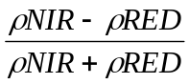 | NDVI_1:NIR:Band34, RED: Band18  NDVI_2: NIR:Band32, RED: Band21  NDVI_3:NIR:Band34, RED:Band09  NDVI_4:NIR:Band27 RED:Band19 | NDVI_1:NIR:Band57, RED: Band32  NDVI_2: NIR:Band49, RED: Band37  NDVI_3:NIR:Band57, RED:Band20  NDVI_4:NIR:Band44 RED:Band34 | -1 to 1  Common range for green vegetation is 0.2 to 0.8 | Using of the highest absorption and reflectance regions of chlorophyll.
Sum Green Index | Mean of reflectance across the 500 nm to 600 nm portion of the spectrum normalized by the number of bands. | Bands 4-12  (centers 511-602nm) | Bands 13-24  (centers 500-603nm) | 0-50  Common range for green vegetation is 10 to 25. | Highly sensitive to small changes in vegetation canopy opening.
Photochemical Reflectance Index (PRI) | 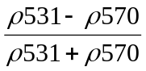 | Band06 (center 532nm) Band10 (center 581nm) | Band16 (center 528nm) Band21 (center 574nm) | -1 to 1  Common range for green vegetation is  -0.2 to 0.2. | Sensitive to changes in carotenoid pigments in live foliage.
Structure Insensitive Pigment Index (SIPI) | 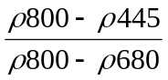 | Band27 (center 798), Band18 (center680) and Band01 (center454) | Band45 (center 804), Band32 (center679) and Band07 (center445) | 0 to 2  Common range for green vegetation is 0.8 to 1.8. | Maximized sensitivity to the ratio of bulk carotenoids to chlorophyll, while decreasing sensitivity to variation in canopy structure. Increases in SIPI indicate increased canopy stress.
Plant Senescence Reflectance Index (PSRI) | 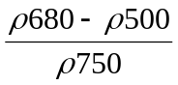 | Band24 (center 749), Band03 (center498) and Band18 (center680) | Band40 (center755), Band13 (center500) and Band32 (center 680) | -1 to 1  Common range for green vegetation is -0.1 to 0.2. | Maximizes the sensitivity to the ratio of bulk carotenoids to chlorophyll. An increase in PSRI indicates increased canopy stress.

Table 3. Comparing locations based on ground elevation

Dependent Variable: ground elevation
Treatment | LOCATION | Mean | Std. Deviation | N
H | FC | 2.304533 | .0436538 | 3
 | LY | 2.323333 | .2657693 | 3
 | RB | 2.115500 | .1268493 | 3
 | SSM | 2.290667 | .0130128 | 3
 | Total | 2.258508 | .1540415 | 12
S | FC | 1.926667 | .2107922 | 3
 | LY | 2.246667 | .0971253 | 3
 | RB | 1.683333 | .3397548 | 3
 | SSM | 2.453333 | .2098412 | 3
 | Total | 2.077500 | .3656408 | 12
V | FC | 2.072918 | .2715332 | 3
 | LY | 2.260000 | .3702702 | 3
 | RB | 1.820000 | .0529150 | 3
 | SSM | 2.673333 | .1457166 | 3
 | Total | 2.206563 | .3853916 | 12
Total | FC | 2.101373 | .2392585 | 9
 | LY | 2.276667 | .2356905 | 9
 | RB | 1.872944 | .2649090 | 9
 | SSM | 2.472444 | .2098113 | 9
 | Total | 2.180857 | .3195494 | 36

Table 4. Comparing locations based on seasons and sulfide concentration in the sediment

Dependent Variable: SULFIDE
Treatment | SEASON | LOCATION | Mean | Std. Deviation | N
H | Fall | FC | .25246 | .098781 | 3
H | Fall | LY | .15051 | .037129 | 3
H | Fall | RB | .09051 | .043253 | 3
H | Fall | SSM | .11781 | .021766 | 3
H | Fall | Total | .15282 | .080951 | 12
H | Spring | FC | 2.18582 | 3.060707 | 3
H | Spring | LY | 3.18929 | 2.091023 | 3
H | Spring | RB | .04937 | .012265 | 3
H | Spring | SSM | 8.35849 | 6.976500 | 3
H | Spring | Total | 3.44574 | 4.639700 | 12
H | Summer | FC | .63233 | .230233 | 3
H | Summer | LY | .24227 | .142173 | 3
H | Summer | RB | .16047 | .007426 | 3
H | Summer | SSM | 4.35136 | 4.314714 | 3
H | Summer | Total | 1.34661 | 2.591520 | 12
H | Total | FC | 1.02354 | 1.773307 | 9
H | Total | LY | 1.19402 | 1.827414 | 9
H | Total | RB | .10011 | .053715 | 9
H | Total | SSM | 4.27589 | 5.436755 | 9
H | Total | Total | 1.64839 | 3.283910 | 36
S | Fall | FC | .06648 | .036526 | 3
S | Fall | LY | .14949 | .057158 | 3
S | Fall | RB | .13254 | .078076 | 3
S | Fall | SSM | .09257 | .055902 | 3
S | Fall | Total | .11027 | .060633 | 12
S | Spring | FC | .38885 | .292740 | 3
S | Spring | LY | 3.02131 | 2.344209 | 3
S | Spring | RB | .04278 | .028248 | 3
S | Spring | SSM | 3.80168 | 6.263492 | 3
S | Spring | Total | 1.81365 | 3.321506 | 12
S | Summer | FC | .37624 | .325188 | 3
S | Summer | LY | 2.06693 | 3.342433 | 3
S | Summer | RB | .15312 | .085480 | 3
S | Summer | SSM | .34784 | .254996 | 3
S | Summer | Total | .73603 | 1.647962 | 12
S | Total | FC | .27719 | .270552 | 9
S | Total | LY | 1.74591 | 2.402489 | 9
S | Total | RB | .10948 | .078307 | 9
S | Total | SSM | 1.41403 | 3.611624 | 9
S | Total | Total | .88665 | 2.197972 | 36

V | Fall | FC | .07405 | .043458 | 3
V | Fall | LY | .10814 | .011874 | 3
V | Fall | RB | .08305 | .089943 | 3
V | Fall | SSM | .06480 | .022907 | 3
V | Fall | Total | .08251 | .047112 | 12
V | Spring | FC | .26402 | .191461 | 3
V | Spring | LY | .46088 | .220904 | 3
V | Spring | RB | .23697 | .168532 | 3
V | Spring | SSM | .52393 | .484520 | 3
V | Spring | Total | .37145 | .282821 | 12
V | Summer | FC | .29468 | .207853 | 3
V | Summer | LY | .15824 | .097242 | 3
V | Summer | RB | .18619 | .085441 | 3
V | Summer | SSM | .27293 | .062353 | 3
V | Summer | Total | .22801 | .123189 | 12
V | Total | FC | .21092 | .176493 | 9
V | Total | LY | .24242 | .204733 | 9
V | Total | RB | .16874 | .124746 | 9
V | Total | SSM | .28722 | .315330 | 9
V | Total | Total | .22732 | .211939 | 36
Total | Fall | FC | .13100 | .107490 | 9
Total | Fall | LY | .13605 | .040435 | 9
Total | Fall | RB | .10203 | .067440 | 9
Total | Fall | SSM | .09173 | .039475 | 9
Total | Fall | Total | .11520 | .069084 | 36
Total | Spring | FC | .94623 | 1.799951 | 9
Total | Spring | LY | 2.22383 | 2.057340 | 9
Total | Spring | RB | .10970 | .128282 | 9
Total | Spring | SSM | 4.22803 | 5.800474 | 9
Total | Spring | Total | 1.87695 | 3.446784 | 36
Total | Summer | FC | .43442 | .271606 | 9
Total | Summer | LY | .82248 | 1.916463 | 9
Total | Summer | RB | .16659 | .062384 | 9
Total | Summer | SSM | 1.65738 | 2.958856 | 9
Total | Summer | Total | .77022 | 1.784415 | 36
Total | Total | FC | .50388 | 1.068015 | 27
Total | Total | LY | 1.06078 | 1.793560 | 27
Total | Total | RB | .12611 | .092311 | 27
Total | Total | SSM | 1.99238 | 4.008265 | 27
Total | Total | Total | .92079 | 2.337254 | 108
Table 5. Comparing locations based on seasons and salinity in the sediment

Dependent Variable: SALINITY
Treatment | SEASON | LOCATION | Mean | Std. Deviation | N
H | Fall | FC | 16.633 | 2.7025 | 3
 |  | LY | 16.167 | .7234 | 3
 |  | RB | 15.233 | 5.0817 | 3
 |  | SSM | 23.333 | 1.0408 | 3
 |  | Total | 17.842 | 4.1903 | 12
 | Spring | FC | 14.400 | 2.4561 | 3
 |  | LY | 11.983 | .7006 | 3
 |  | RB | 13.267 | .5008 | 3
 |  | SSM | 22.400 | 1.0851 | 3
 |  | Total | 15.512 | 4.4151 | 12
 | Summer | FC | 14.967 | 2.4007 | 3
 |  | LY | 14.700 | .5292 | 3
 |  | RB | 15.067 | .0577 | 3
 |  | SSM | 22.133 | 2.0551 | 3
 |  | Total | 16.717 | 3.5435 | 12
 | Total | FC | 15.333 | 2.4053 | 9
 |  | LY | 14.283 | 1.9242 | 9
 |  | RB | 14.522 | 2.7224 | 9
 |  | SSM | 22.622 | 1.3852 | 9
 |  | Total | 16.690 | 4.0647 | 36
S | Fall | FC | 18.567 | 2.1127 | 3
 |  | LY | 16.667 | .4041 | 3
 |  | RB | 15.300 | 5.8026 | 3
 |  | SSM | 22.333 | 1.4742 | 3
 |  | Total | 18.217 | 3.8715 | 12
 | Spring | FC | 12.750 | 4.2217 | 3
 |  | LY | 10.617 | .4907 | 3
 |  | RB | 12.417 | 1.0116 | 3
 |  | SSM | 16.867 | 1.0408 | 3
 |  | Total | 13.163 | 3.0619 | 12
 | Summer | FC | 14.700 | 2.2605 | 3
 |  | LY | 14.033 | .2309 | 3
 |  | RB | 12.367 | 4.9339 | 3
 |  | SSM | 18.000 | .3606 | 3
 |  | Total | 14.775 | 3.1557 | 12
 | Total | FC | 15.339 | 3.6637 | 9
 |  | LY | 13.772 | 2.6487 | 9
 |  | RB | 13.361 | 4.1078 | 9
 |  | SSM | 19.067 | 2.6627 | 9
 |  | Total | 15.385 | 3.9188 | 36

V | Fall | FC | 19.867 | 1.5373 | 3
V | Fall | LY | 16.867 | 1.1240 | 3
V | Fall | RB | 15.967 | 5.4354 | 3
V | Fall | SSM | 22.100 | 1.1358 | 3
V | Fall | Total | 18.700 | 3.5698 | 12
V | Spring | FC | 13.050 | 2.4140 | 3
V | Spring | LY | 9.100 | .7263 | 3
V | Spring | RB | 14.400 | 1.6523 | 3
V | Spring | SSM | 17.133 | 1.4835 | 3
V | Spring | Total | 13.421 | 3.3469 | 12
V | Summer | FC | 14.867 | 2.5325 | 3
V | Summer | LY | 13.533 | 1.7010 | 3
V | Summer | RB | 15.233 | 1.6197 | 3
V | Summer | SSM | 18.033 | .2309 | 3
V | Summer | Total | 15.417 | 2.2595 | 12
V | Total | FC | 15.928 | 3.6051 | 9
V | Total | LY | 13.167 | 3.5436 | 9
V | Total | RB | 15.200 | 3.0307 | 9
V | Total | SSM | 19.089 | 2.4775 | 9
V | Total | Total | 15.846 | 3.7420 | 36
Total | Fall | FC | 18.356 | 2.3490 | 9
Total | Fall | LY | 16.567 | .7649 | 9
Total | Fall | RB | 15.500 | 4.7310 | 9
Total | Fall | SSM | 22.589 | 1.2077 | 9
Total | Fall | Total | 18.253 | 3.7896 | 36
Total | Spring | FC | 13.400 | 2.8284 | 9
Total | Spring | LY | 10.567 | 1.3693 | 9
Total | Spring | RB | 13.361 | 1.3205 | 9
Total | Spring | SSM | 18.800 | 2.9015 | 9
Total | Spring | Total | 14.032 | 3.7057 | 36
Total | Summer | FC | 14.844 | 2.0821 | 9
Total | Summer | LY | 14.089 | 1.0313 | 9
Total | Summer | RB | 14.222 | 2.9469 | 9
Total | Summer | SSM | 19.389 | 2.3105 | 9
Total | Summer | Total | 15.636 | 3.0580 | 36
Total | Total | FC | 15.533 | 3.1607 | 27
Total | Total | LY | 13.741 | 2.7162 | 27
Total | Total | RB | 14.361 | 3.3011 | 27
Total | Total | SSM | 20.259 | 2.7495 | 27
Total | Total | Total | 15.974 | 3.9119 | 108
Table 6. Comparing locations based on seasons and oxygen redox potential in the sediment
Dependent Variable: ORP
Treatment | SEASON | LOCATION | Mean | Std. Deviation | N
H | Fall | FC | -297.000 | 15.7162 | 3
 |  | LY | -262.667 | 2.0817 | 3
 |  | RB | -227.933 | 10.7058 | 3
 |  | SSM | -234.000 | 26.0000 | 3
 |  | Total | -255.400 | 31.7248 | 12
 | Spring | FC | -270.500 | 26.3581 | 3
 |  | LY | -273.817 | 10.8571 | 3
 |  | RB | -222.500 | 26.2869 | 3
 |  | SSM | -262.333 | 24.2916 | 3
 |  | Total | -257.288 | 28.9791 | 12
 | Summer | FC | -266.000 | 45.8258 | 3
 |  | LY | -316.333 | 23.7136 | 3
 |  | RB | -234.333 | 32.7159 | 3
 |  | SSM | -305.667 | 73.2826 | 3
 |  | Total | -280.583 | 53.0719 | 12
 | Total | FC | -277.833 | 31.1589 | 9
 |  | LY | -284.272 | 27.7966 | 9
 |  | RB | -228.256 | 22.2553 | 9
 |  | SSM | -267.333 | 51.3438 | 9
 |  | Total | -264.424 | 40.0048 | 36
S | Fall | FC | -220.333 | 40.5257 | 3
 |  | LY | -231.000 | 22.3383 | 3
 |  | RB | -237.667 | 52.5389 | 3
 |  | SSM | -190.333 | 57.9511 | 3
 |  | Total | -219.833 | 43.1274 | 12
 | Spring | FC | -236.500 | 49.4798 | 3
 |  | LY | -257.667 | 8.6217 | 3
 |  | RB | -251.000 | 14.4135 | 3
 |  | SSM | -245.000 | 25.2339 | 3
 |  | Total | -247.542 | 26.0467 | 12
 | Summer | FC | -222.333 | 87.8427 | 3
 |  | LY | -290.000 | 47.5079 | 3
 |  | RB | -206.667 | 84.8901 | 3
 |  | SSM | -263.333 | 61.9785 | 3
 |  | Total | -245.583 | 70.7563 | 12
 | Total | FC | -226.389 | 54.8633 | 9
 |  | LY | -259.556 | 36.9090 | 9
 |  | RB | -231.778 | 54.1445 | 9
 |  | SSM | -232.889 | 55.1434 | 9
 |  | Total | -237.653 | 50.3507 | 36

V | Fall | FC | -201.333 | 90.1240 | 3
V | Fall | LY | -190.000 | 82.7768 | 3
V | Fall | RB | -197.733 | 86.1790 | 3
V | Fall | SSM | -159.333 | 63.1057 | 3
V | Fall | Total | -187.100 | 71.3838 | 12
V | Spring | FC | -168.333 | 39.4631 | 3
V | Spring | LY | -229.567 | 25.6137 | 3
V | Spring | RB | -181.500 | 46.0733 | 3
V | Spring | SSM | -210.500 | 74.5939 | 3
V | Spring | Total | -197.475 | 49.2791 | 12
V | Summer | FC | -193.667 | 80.9280 | 3
V | Summer | LY | -253.000 | 62.8649 | 3
V | Summer | RB | -191.333 | 66.8755 | 3
V | Summer | SSM | -230.667 | 97.1253 | 3
V | Summer | Total | -217.167 | 71.9038 | 12
V | Total | FC | -187.778 | 65.4289 | 9
V | Total | LY | -224.189 | 60.2119 | 9
V | Total | RB | -190.189 | 59.6290 | 9
V | Total | SSM | -200.167 | 75.8889 | 9
V | Total | Total | -200.581 | 64.4170 | 36
Total | Fall | FC | -239.556 | 66.5340 | 9
Total | Fall | LY | -227.889 | 53.2387 | 9
Total | Fall | RB | -221.111 | 53.8574 | 9
Total | Fall | SSM | -194.556 | 55.3130 | 9
Total | Fall | Total | -220.778 | 57.4676 | 36
Total | Spring | FC | -225.111 | 56.6143 | 9
Total | Spring | LY | -253.683 | 24.2514 | 9
Total | Spring | RB | -218.333 | 40.8756 | 9
Total | Spring | SSM | -239.278 | 47.1163 | 9
Total | Spring | Total | -234.101 | 44.1199 | 36
Total | Summer | FC | -227.333 | 71.3197 | 9
Total | Summer | LY | -286.444 | 49.5180 | 9
Total | Summer | RB | -210.778 | 59.5268 | 9
Total | Summer | SSM | -266.556 | 75.6424 | 9
Total | Summer | Total | -247.778 | 69.1049 | 36
Total | Total | FC | -230.667 | 62.8908 | 27
Total | Total | LY | -256.006 | 49.0284 | 27
Total | Total | RB | -216.741 | 50.1666 | 27
Total | Total | SSM | -233.463 | 65.5728 | 27
Total | Total | Total | -234.219 | 58.3242 | 108
Table 7a Showing Tests of Between-Subjects Effects regarding ground elevation

Dependent Variable: ground elevation
Source |  | Type III Sum of Squares | df | Mean Square | F | Sig.
Intercept | Hypothesis | 171.221 | 1 | 171.221 | 292.190 | .000
Intercept | Error | 1.758 | 3 | .586(a)
TREATMEN | Hypothesis | .208 | 2 | .104 | 1.172 | .372
TREATMEN | Error | .533 | 6 | .089(b)
LOCATION | Hypothesis | 1.758 | 3 | .586 | 6.591 | .025
LOCATION | Error | .533 | 6 | .089(b)
TREATMEN * LOCATION | Hypothesis | .533 | 6 | .089 | 1.987 | .107
TREATMEN * LOCATION | Error | 1.074 | 24 | .045(c)
a MS(LOCATION)
b MS(TREATMEN * LOCATION)
c MS(Error)

Table 7b Showing Multiple Comparisons - Bonferroni test regarding ground elevation

Dependent Variable: ground elevation
(I) Treatment | (J) Treatment | Mean Difference (I-J) | Std. Error | Sig. | 95% Confidence Interval
 |  |  |  |  | Lower Bound | Upper Bound
H | S | .181008 | .0863613 | .140 | -.041255 | .403271
H | V | .051945 | .0863613 | 1.000 | -.170318 | .274209
S | H | -.181008 | .0863613 | .140 | -.403271 | .041255
 | V | -.129063 | .0863613 | .444 | -.351326 | .093200
V | H | -.051945 | .0863613 | 1.000 | -.274209 | .170318
 | S | .129063 | .0863613 | .444 | -.093200 | .351326
Based on observed means.

Table 8a Showing Tests of Between-Subjects Effects regarding sulfide concentration in sediment

Dependent Variable: SULFIDE
Source |  | Type III Sum of Squares | df | Mean Square | F | Sig.
Intercept | Hypothesis | 91.568 | 1 | 91.568 | 5.156 | .108
Intercept | Error | 53.277 | 3 | 17.759(a)
TREATMEN | Hypothesis | 36.413 | 2 | 18.206 | 2.031 | .212
TREATMEN | Error | 53.798 | 6 | 8.966(b)
SEASON | Hypothesis | 57.092 | 2 | 28.546 | 3.817 | .085
SEASON | Error | 44.873 | 6 | 7.479(c)
LOCATION | Hypothesis | 53.277 | 3 | 17.759 | 1.318 | .336
LOCATION | Error | 104.176 | 7.734 | 13.470(d)
TREATMEN * SEASON | Hypothesis | 27.926 | 4 | 6.981 | 2.346 | .113
TREATMEN * SEASON | Error | 35.705 | 12 | 2.975(e)
TREATMEN * LOCATION | Hypothesis | 53.798 | 6 | 8.966 | 3.013 | .049
TREATMEN * LOCATION | Error | 35.705 | 12 | 2.975(e)
SEASON * LOCATION | Hypothesis | 44.873 | 6 | 7.479 | 2.514 | .082
SEASON * LOCATION | Error | 35.705 | 12 | 2.975(e)
TREATMEN * SEASON * LOCATION | Hypothesis | 35.705 | 12 | 2.975 | .778 | .671
TREATMEN * SEASON * LOCATION | Error | 275.431 | 72 | 3.825(f)
a MS(LOCATION)
b MS(TREATMEN * LOCATION)
c MS(SEASON * LOCATION)
d MS(TREATMEN * LOCATION) + MS(SEASON * LOCATION) - MS(TREATMEN * SEASON * LOCATION)
e MS(TREATMEN * SEASON * LOCATION)
f MS(Error)

Table 8b Showing Multiple Comparisons - Bonferroni test regarding sulfide concentration in sediment

Dependent Variable: SULFIDE
(I) Treatment | (J) Treatment | Mean Difference (I-J) | Std. Error | Sig. | 95% Confidence Interval
 |  |  |  |  | Lower Bound | Upper Bound
H | S | .76174 | .461003 | .308 | -.36827 | 1.89175
H | V | 1.42107(*) | .461003 | .009 | .29106 | 2.55108
S | H | -.76174 | .461003 | .308 | -1.89175 | .36827
 | V | .65933 | .461003 | .471 | -.47068 | 1.78934
V | H | -1.42107(*) | .461003 | .009 | -2.55108 | -.29106
 | S | -.65933 | .461003 | .471 | -1.78934 | .47068
Based on observed means.
* The mean difference is significant at the .05 level.
Table 9a Showing Tests of Between-Subjects Effects regarding salinity in sediment

Dependent Variable: SALINITY
Source |  | Type III Sum of Squares | df | Mean Square | F | Sig.
Intercept | Hypothesis | 27556.875 | 1 | 27556.875 | 117.105 | .002
Intercept | Error | 705.955 | 3 | 235.318(a)
TREATMEN | Hypothesis | 31.562 | 2 | 15.781 | 1.411 | .315
TREATMEN | Error | 67.111 | 6 | 11.185(b)
SEASON | Hypothesis | 326.829 | 2 | 163.414 | 19.849 | .002
SEASON | Error | 49.398 | 6 | 8.233(c)
LOCATION | Hypothesis | 705.955 | 3 | 235.318 | 13.158 | .001
LOCATION | Error | 176.858 | 9.889 | 17.884(d)
TREATMEN * SEASON | Hypothesis | 36.226 | 4 | 9.057 | 5.905 | .007
TREATMEN * SEASON | Error | 18.405 | 12 | 1.534(e)
TREATMEN * LOCATION | Hypothesis | 67.111 | 6 | 11.185 | 7.293 | .002
TREATMEN * LOCATION | Error | 18.405 | 12 | 1.534(e)
SEASON * LOCATION | Hypothesis | 49.398 | 6 | 8.233 | 5.368 | .007
SEASON * LOCATION | Error | 18.405 | 12 | 1.534(e)
TREATMEN * SEASON * LOCATION | Hypothesis | 18.405 | 12 | 1.534 | .275 | .992
TREATMEN * SEASON * LOCATION | Error | 401.922 | 72 | 5.582(f)
a MS(LOCATION)
b MS(TREATMEN * LOCATION)
c MS(SEASON * LOCATION)
d MS(TREATMEN * LOCATION) + MS(SEASON * LOCATION) - MS(TREATMEN * SEASON * LOCATION)
e MS(TREATMEN * SEASON * LOCATION)
f MS(Error)

Table 9b Showing Multiple Comparisons - Bonferroni test regarding salinity in sediment

Dependent Variable: SALINITY
(I) Treatment | (J) Treatment | Mean Difference (I-J) | Std. Error | Sig. | 95% Confidence Interval
 |  |  |  |  | Lower Bound | Upper Bound
H | S | 1.306 | .5569 | .065 | -.059 | 2.671
H | V | .844 | .5569 | .401 | -.521 | 2.209
S | H | -1.306 | .5569 | .065 | -2.671 | .059
 | V | -.461 | .5569 | 1.000 | -1.826 | .904
V | H | -.844 | .5569 | .401 | -2.209 | .521
 | S | .461 | .5569 | 1.000 | -.904 | 1.826
Based on observed means.
Table 10a Showing Tests of Between-Subjects Effects regarding oxygen redox potential in sediment

Dependent Variable: ORP
Source |  | Type III Sum of Squares | df | Mean Square | F | Sig.
Intercept | Hypothesis | 5145527.540 | 1 | 5145527.540 | 641.305 | .000
Intercept | Error | 24070.574 | 3 | 8023.525(a)
TREATMEN | Hypothesis | 123908.027 | 2 | 61954.014 | 15.440 | .004
TREATMEN | Error | 24074.995 | 6 | 4012.499(b)
SEASON | Hypothesis | 21338.919 | 2 | 10669.459 | .810 | .488
SEASON | Error | 78995.986 | 6 | 13165.998(c)
LOCATION | Hypothesis | 24070.574 | 3 | 8023.525 | .753 | .585
LOCATION | Error | 34420.043 | 3.231 | 10652.856(d)
TREATMEN * SEASON | Hypothesis | 47413.507 | 4 | 11853.377 | 1.816 | .191
TREATMEN * SEASON | Error | 78307.692 | 12 | 6525.641(e)
TREATMEN * LOCATION | Hypothesis | 24074.995 | 6 | 4012.499 | .615 | .715
TREATMEN * LOCATION | Error | 78307.692 | 12 | 6525.641(e)
SEASON * LOCATION | Hypothesis | 78995.986 | 6 | 13165.998 | 2.018 | .142
SEASON * LOCATION | Error | 78307.692 | 12 | 6525.641(e)
TREATMEN * SEASON * LOCATION | Hypothesis | 78307.692 | 12 | 6525.641 | .631 | .809
TREATMEN * SEASON * LOCATION | Error | 745067.232 | 72 | 10348.156(f)
a MS(LOCATION)
b MS(TREATMEN * LOCATION)
c MS(SEASON * LOCATION)
d MS(TREATMEN * LOCATION) + MS(SEASON * LOCATION) - MS(TREATMEN * SEASON * LOCATION)
e MS(TREATMEN * SEASON * LOCATION)
f MS(Error)

Table 10b Showing Multiple Comparisons - Bonferroni test regarding salinity in sediment

Dependent Variable: ORP
(I) Treatment | (J) Treatment | Mean Difference (I-J) | Std. Error | Sig. | 95% Confidence Interval
 |  |  |  |  | Lower Bound | Upper Bound
H | S | -58.104 | 23.9770 | .054 | -116.877 | .668
H | V | -80.343(*) | 23.9770 | .004 | -139.116 | -21.571
S | H | 58.104 | 23.9770 | .054 | -.668 | 116.877
 | V | -22.239 | 23.9770 | 1.000 | -81.011 | 36.534
V | H | 80.343(*) | 23.9770 | .004 | 21.571 | 139.116
 | S | 22.239 | 23.9770 | 1.000 | -36.534 | 81.011
Based on observed means.
* The mean difference is significant at the .05 level.
Table 11. R² Value for the models fitted to the June 07 and Oct 04 Images

 | No. of Observations | June 2007  R² | October 2004  R²
Sulfide-6 | 36 | .33 | .21
Sulfide-8 | 36 | .34 | .15
Sulfide-10 | 36 | .30 | .46
Sulfide-all months | 108 | .15 | .10
Salinity-6 | 36 | .74 | .40
Salinity-8 | 36 | .74 | .43
Salinity-10 | 36 | .47 | .42
Salinity-all months | 108 | .49 | .24
Orp-6 | 36 | .41 | .70
Orp-8 | 36 | .40 | .56
Orp-10 | 36 | .36 | .33
Orp-all months | 108 | .31 | .25
Height | 36 | .65 | .96
Elevation | 36 | .30 | .44
Length of Inflorescenes | 24 | .29 | .76
Stem Density | 24 | .12 | .20
Inter-node Length | 24 | .25 | .48

Table 12. A Comparison of the Models for the June 07 and October 04 Images

 | No.of Observ. | June 07 Images |  |  | October 04 Images
 |  | R² | Residual MS | Sig. Level | R² | Residual MS | Sig. Level
Sulfide* | 12 | .68 | 2.094 | 0.001 | .84 | 0.0006 | < .001
Salinity* | 12 | .86 | 2.234 | 0.001 | .44 | 5.85 | 0.072
Orp* | 12 | .64 | 560 | 0.035 | .88 | 237 | 0.002
Sulfide** | 12 | .67 | 0.520 | 0.001 | .37 | 1.12 | 0.126
Salinity** | 12 | .79 | 2.297 | 0.004 | .63 | 4.730 | 0.099
orp** | 12 | .77 | 377 | 0.021 | .78 | 279 | 0.001
* field measurements are averaged over transects, and are correlated to images with corresponding date.
** field data are averaged over transects and month, and are correlated to the image
Table 13. Summary of the classification accuracy assessment of the 2004 fall image showing the Producer’s accuracy as the percentage of a particular ground class that was correctly classified. The User’s accuracy shows what percentage of a class corresponds to the ground-truthed class. The overall accuracy shows the extent to which the classification procedure correctly classified all classes.

 | Phragmites | Back Marsh | Low Marsh | High Marsh | Mixture | Black Grass | Total | User's Accuracy
Phragmites | 401 | 5 | 4 | 4 | 4 | 0 | 418 | 96
Back Marsh | 3 | 72 | 0 | 0 | 0 | 0 | 75 | 96
Low Marsh | 0 | 4 | 48 | 0 | 0 | 0 | 52 | 92
High Marsh | 21 | 0 | 0 | 160 | 9 | 0 | 190 | 84
Mixture | 7 | 0 | 0 | 17 | 84 | 0 | 108 | 78
Black Grass | 0 | 0 | 0 | 0 | 0 | 20 | 21 | 95
Total | 433 | 81 | 52 | 181 | 97 | 20 | 864
 |  |  |  |  |  |  |  | Overall Accuracy
Producer's Accuracy | 93 | 89 | 92 | 88 | 87 | 100 |  | 90

Table 14. Summary of the classification accuracy assessment of the 2007 summer image showing the Producer’s accuracy as the percentage of a particular ground class that was correctly classified. The User’s accuracy shows what percentage of a class corresponds to the ground-truthed class. The overall accuracy shows the extent to which the classification procedure correctly classified all classes.

 | High marsh (HM) | Phragmites big flower (PBF) | Phragmites small flower (PSF) | Low marsh (LM) | Total | User’s Accuracy
HM | 31 | 5 | 2 | 5 | 43 | 72%
PBF | 19 | 34 | 7 | 8 | 68 | 50%
PSF | 0 | 0 | 27 | 16 | 43 | 62%
LM | 0 | 11 | 11 | 21 | 43 | 48%
Total | 50 | 50 | 47 | 50 | 197
 |  |  |  |  |  | Overall Accuracy
Producer’s Accuracy | 62% | 68% | 57% | 42% |  | 56.5%

Table 15. Summary of the classification accuracy assessment of the 2007 summer image when ground elevation was used to enhance classification accuracy.

 | High marsh (HM) | Phragmites big flower (PBF) | Phragmites small flower (PSF) | Low marsh (LM) | Total | User’s Accuracy
HM | 48 | 1 | 1 | 2 | 52 | 92%
PBF | 2 | 35 | 9 | 7 | 53 | 66%
PSF | 0 | 6 | 23 | 11 | 40 | 58%
LM | 0 | 8 | 16 | 30 | 54 | 56%
Total | 50 | 50 | 49 | 50 | 199
 |  |  |  |  |  | Overall Accuracy
Producer’s Accuracy | 96% | 70% | 47% | 60% |  | 68.3%
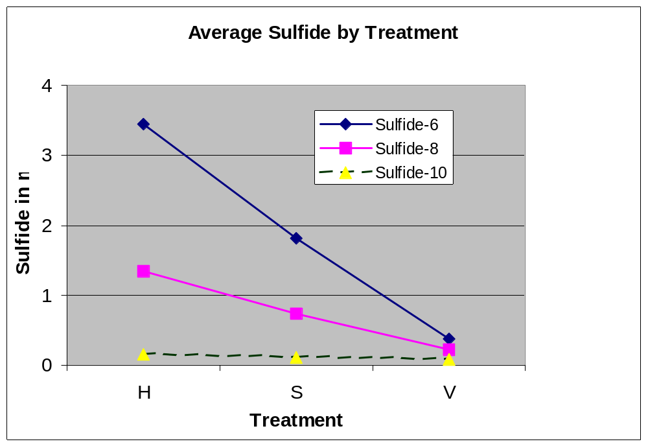
Figure 1. Sulfide data in different treatments along the growing season.

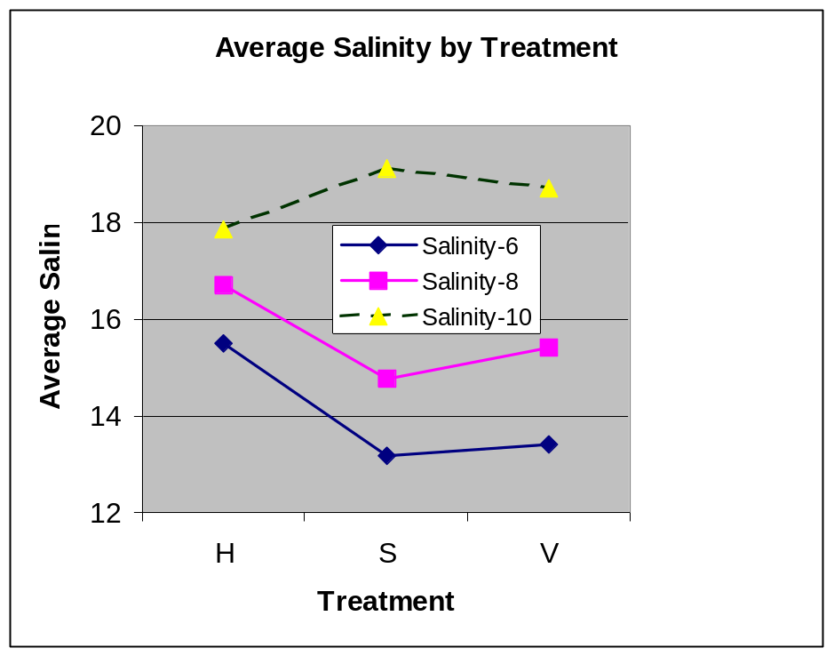
Figure 2. Salinity data in different treatments along the growing season.
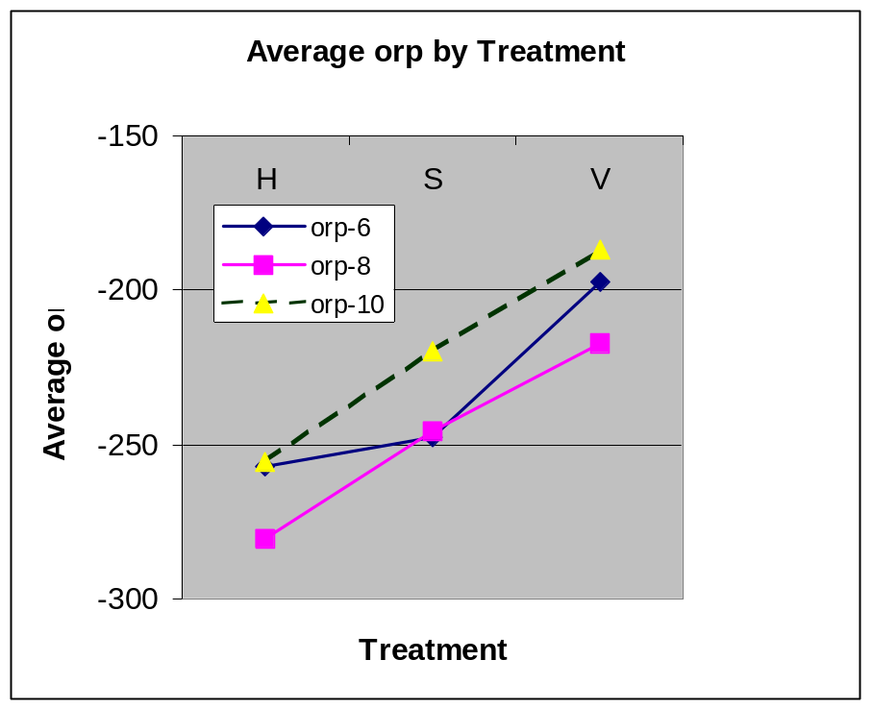
Figure 3. Oxidation-reduction potential in different treatments along the growing season.

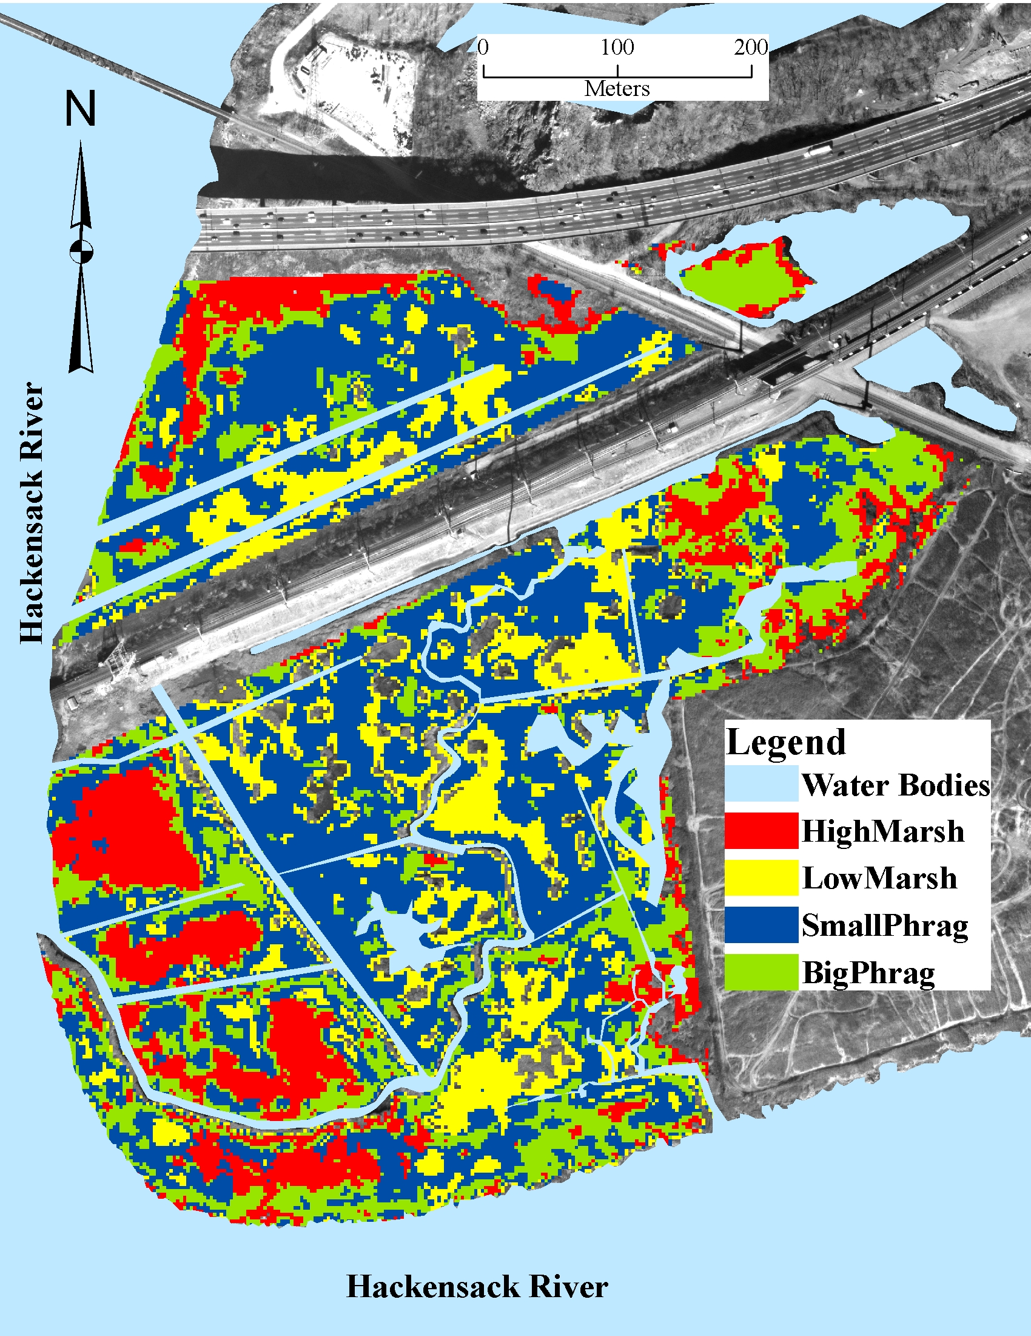
Figure 4. SAM classification of the 2004 October image at Riverbend Wetland Preserve
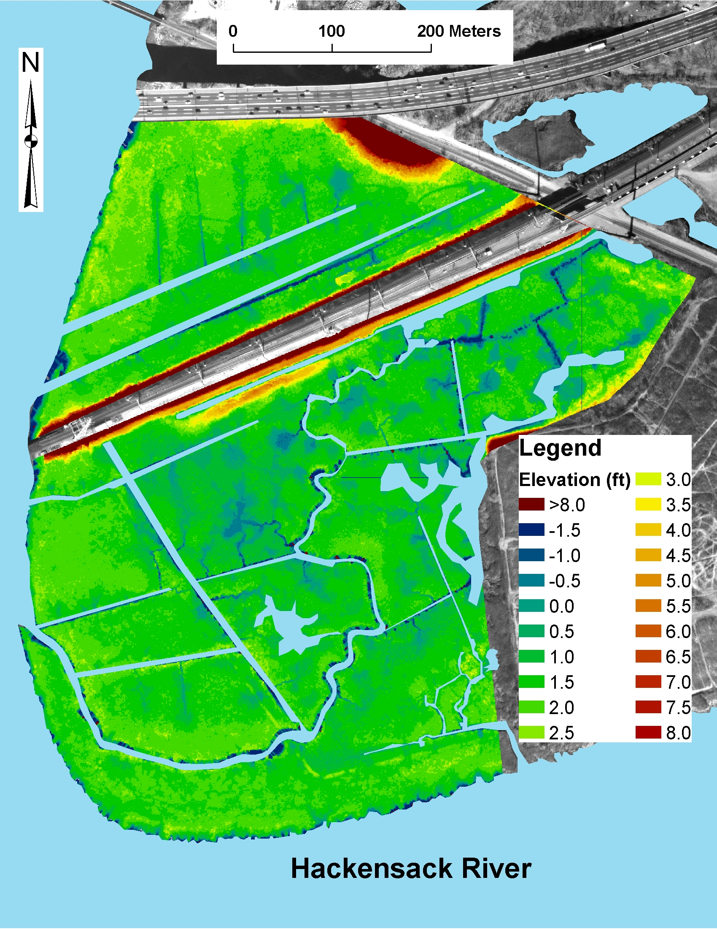
Figure 5. LIDAR ground elevation image of the Riverbend Wetland Preserve
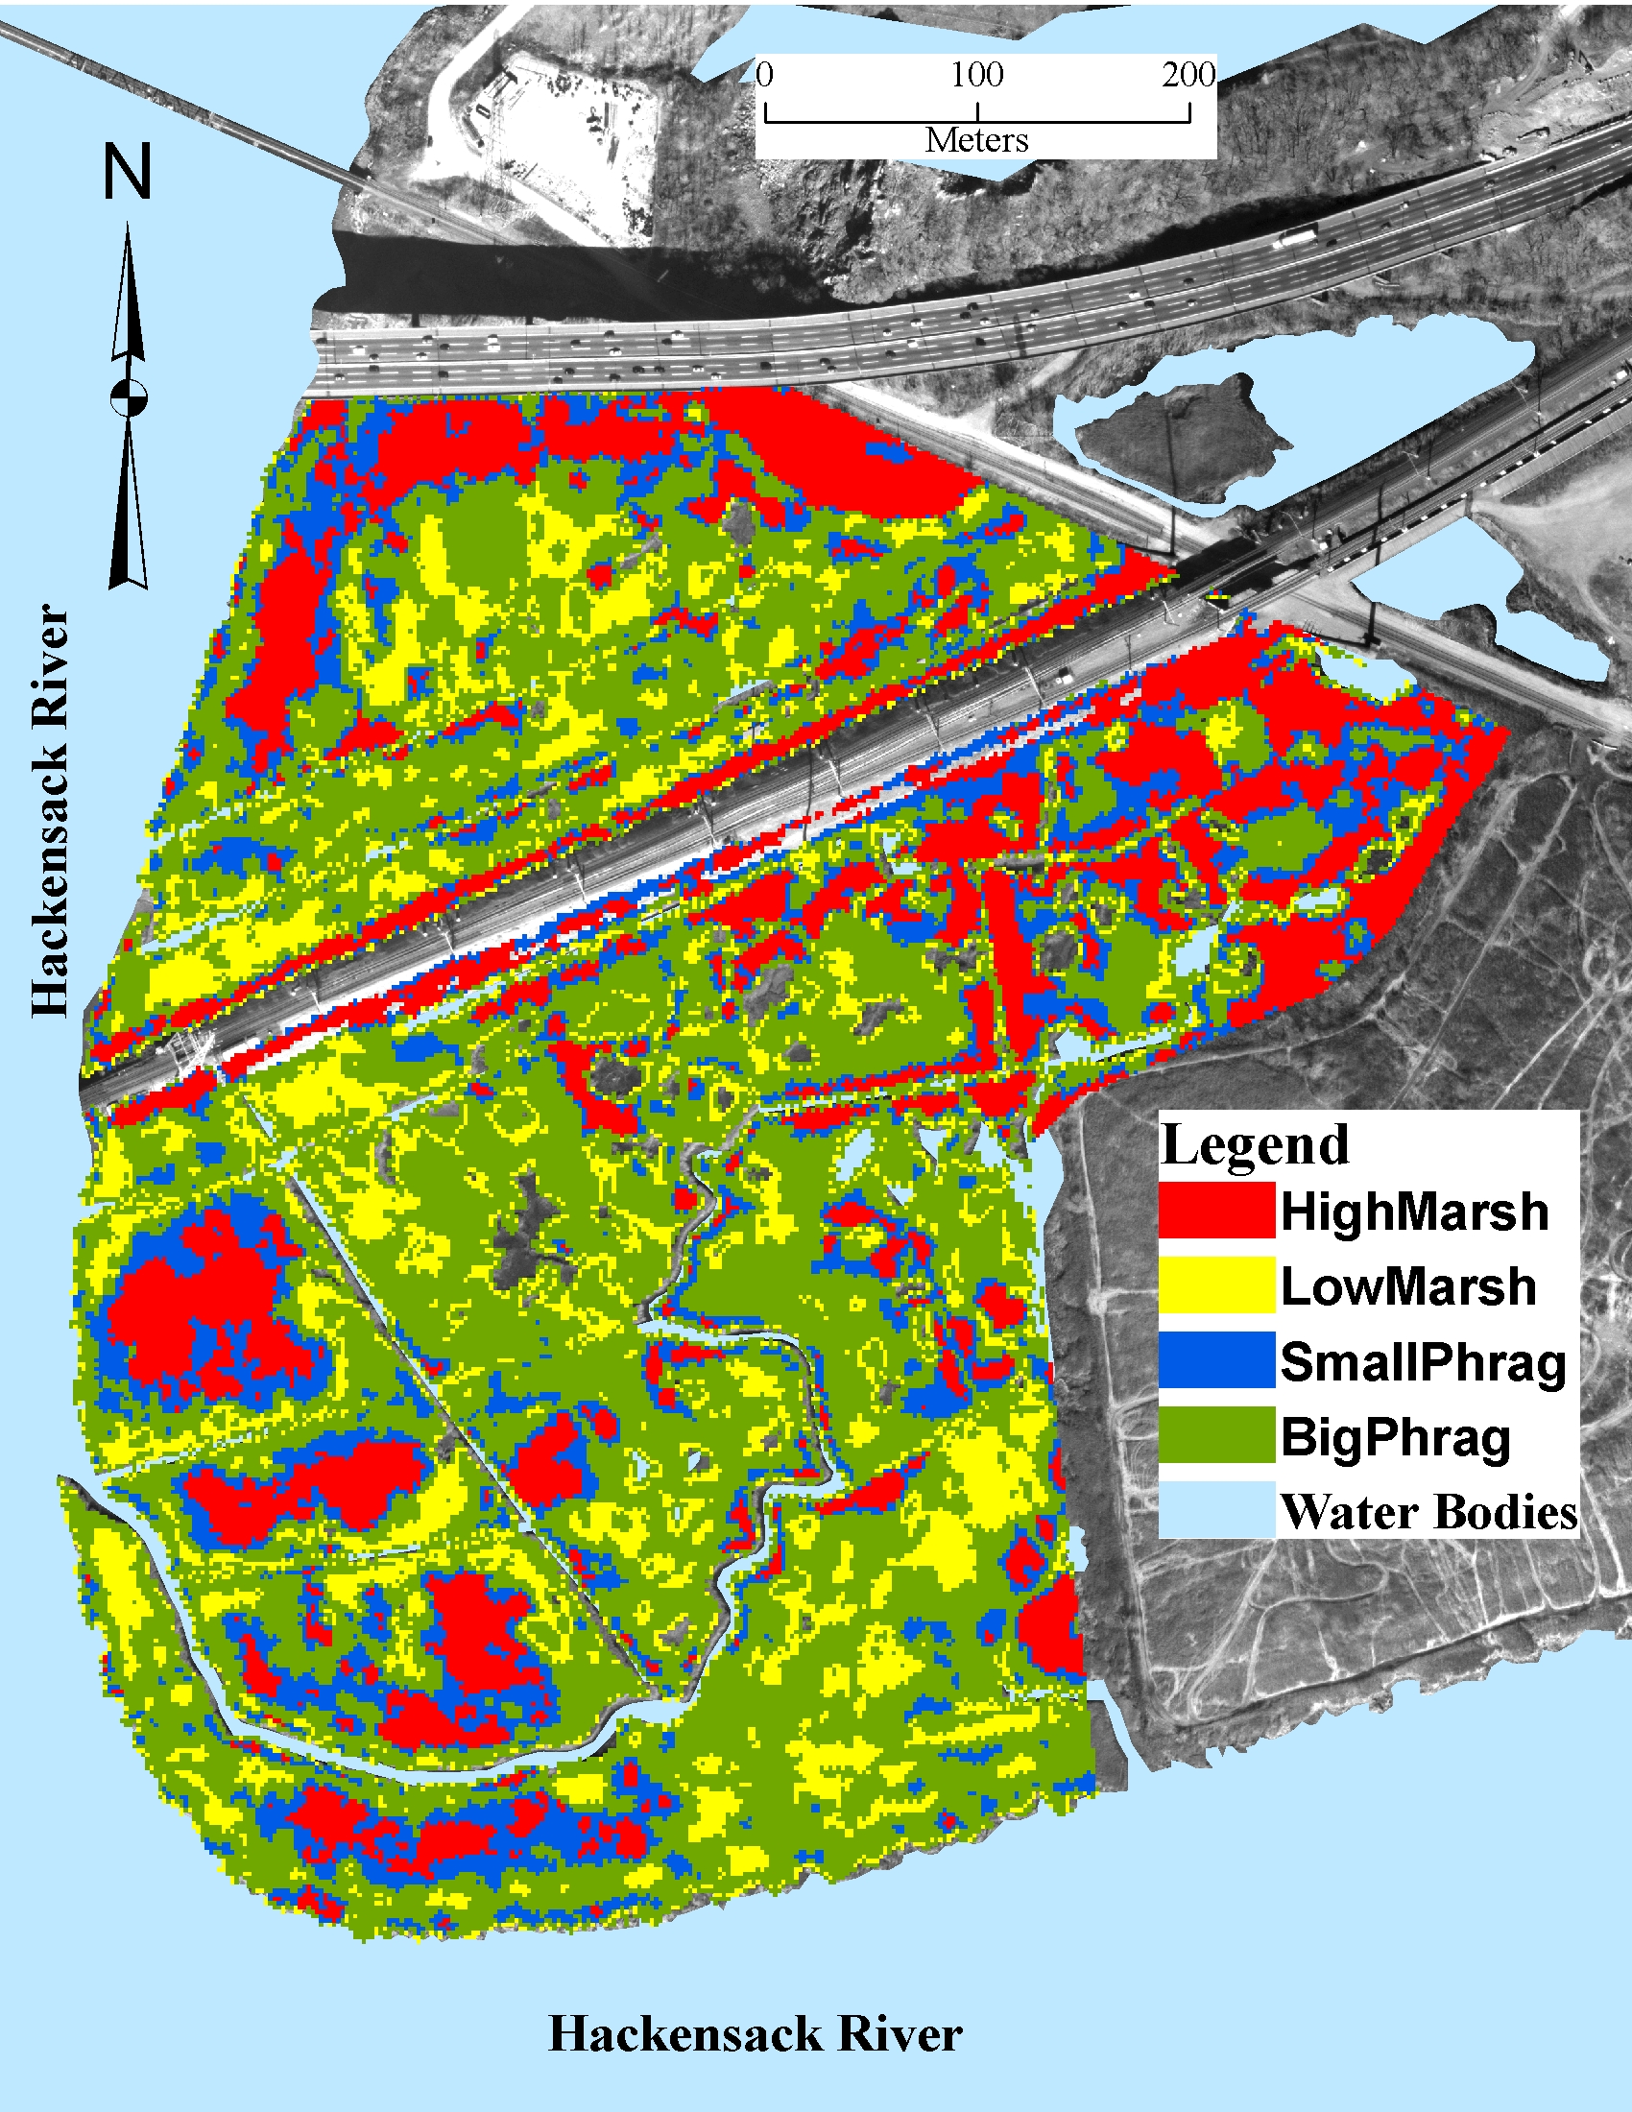
Figure 6. 2007 June AISA classification image after applying ground elevation data to the classification.

8. Acknowledgements

We would like to thank EPA Region 2 for funding this project. In addition, we would like to thank the following individuals and universities for their participations:

Jiansheng (Jason) Yang, Ph.D.
Associate Professor
Department of Geography
CL426
Ball State University
Muncie, IN

Dr. Aridaman K. Jain
Senior University Lecturer
New Jersey Institute of Technology
Newark, NJ

Ildiko Csokane Pechmann Ph.D.
Post-Doctorate Fellow
Rutgers University
Newark, NJ

Thenkabail P.S., Smith, R.B., and De-Pauw, E. 2000b. Hyperspectral vegetation indices for determining agricultural crop characteristics. Remote sensing of Environment. 71:158-182.
Gamon, J.A. and J. Surfus 1999. Assessing Leaf Pigment Content and Activity with a Reflectometer. New Phytologist 143(1):105-117.
Gamon, J.A., J. Penuelas, and C.B. Field, 1992. A Narrow-Waveband Spectral Index That Tracks Diurnal Changes in Photosynthetic Efficiency. Remote Sensing of Environment 41:35-44.
Gamon, J.A., L. Serrano, and J.S. Surfus, 1997. The Photochemical Reflectance Index: An Optical Indicator of Photosynthetic Radiation Use Efficiency Across Species, Functional Types and Nutrient Levels. Oecologia 112:492-501.
Penuelas, J., F. Baret, and I. Filella, 1995. Semi-Empirical Indices to Assess Carotenoids/Chlorophyll-a Ratio from Leaf Spectral Reflectance. Photosynthetica 31:221-230.
Merzlyak, J.R., A.A. Gitelson, O.B. Chivkunova, and V.Y. Rakitin, 1999. Non-destructive Optical Detection of Pigment Changes During Leaf Senescence and Fruit Ripening. Physiologia Plantarum 106:135-141.
Landis, J. & Koch, G. G. (1977). The measurement of observer agreement for categorical data. Biometrics, (33), 159-174.

